Design Philosophy
IMPORTANT – the first half of this document details my original design for the levels, but that has now changed since Pat’s feedback. To see the changes made and the newest version of the levels, please go to “Making Levels for a Possible Update” on Page 80.

When testing the base game of death squared on some family members, I noticed a lot of confusion over the second level. The second level introduces several mechanics at once – holocubes, moving blocks, spikes, and pressure plates, all of which interact with each other. While this does create an exciting level experience, I thought it would be interesting to see what it would look like to make a version of the game that spends more time onboarding the player with the basics before introducing complexity, and really unpacking all the possibilities of any given mechanic. This means that new mechanics are introduced more gradually, (spikes don’t appear until about 25 levels in), but also that unique movement options and edge cases that didn’t appear in the original game are explored.

Possible Solution Sentences
- Two pairs of robots need to weave between each other (Level 2)
- Two pairs of robots need to weave between each other (one split vertically, the other horizontally) (Level 3)
- Reach the goals by cutting corners (Level 5, and Level 7 with both players)
- Two pairs of robots need to weave between each other by cutting corners (Level 6)
- Two pairs of robots need to weave between each other by cutting corners (one split vertically, the other horizontally) (Level 8)
- Launch a player over a gap with a moving cube (Level 9)
- Launch both players over a long gap with a moving cube – one on top of the other (Level 11)
- Two pairs of players with half of each pair on top of a holocube maze, and the other half within the holocube maze (Level 13)
- One player moves along the top of a holocube maze, the other along the bottom, and they need to swap when they get to the end and then go back through the maze on the other layer (Level 14)
- Split up the two pairs so they can weave between each other (Level 15)
- Split up the two pairs so they can weave between each other (one split vertically, the other horizontally) (Level 18)
- Split up the two pairs so they can weave between each other by cutting corners (Level 19)
- Split up the two pairs so they can weave between each other by cutting corners (one split vertically, the other horizontally) (Level 20)
- Players swap positions within a shared spike maze (Level 21)
- Both players move through their own spike maze with pressure plates in them, each of which affects the other maze (Level 22)
- Lift a player on to the walls of a maze with a triggered mover (Level 23)
- Moving cubes mean player can only deactivate spikes for a second at a time, which means the other player has to time their movement for when the spikes are deactivated (Level 24)
- One player has to carry another in order to stop another of the same colour from falling off the stage
- Red carries blue and then blue carries red
- Two pairs – one of blue carries one of red while one of red carries one of blue
- Launch a player upwards with a moving holocube
- Split up pairs using only pressing against the other players, no walls
- Use a costume with a large hat to carry another player while inside a holocube, so that you can move that player along the holocube path without messing up the pathing of its pair
- One player moves off the top of another player while they are both falling (DON’T DO THIS – based on testing, will be much too finicky for players)
- One player moves off the top of another player while they are midair after being launched by a moving cube (DON’T DO THIS – based on testing, will be much too finicky for players)

Death Squared Level Iterations
It’s important to note that these levels are listed in the order created, but not the order they appear in engine. Because I wanted this version of the game to focus on exploring the different ways mechanics can be used (i.e. having one level introduce a concept and the following level expand on that concept), the order was very important. I reordered the levels based on their features and the level of understanding required for them, using this table:
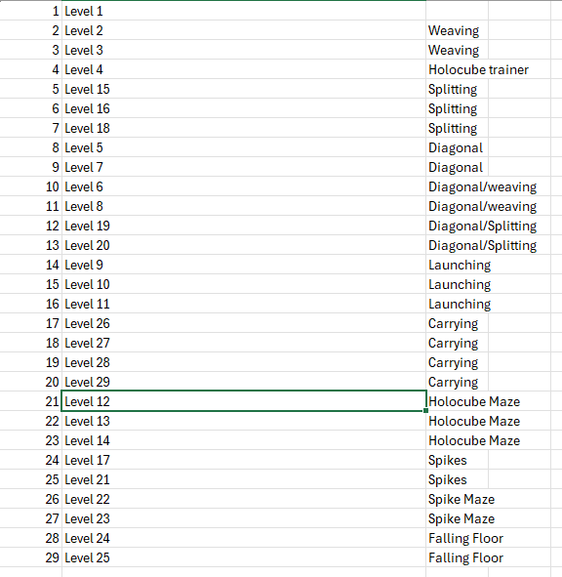
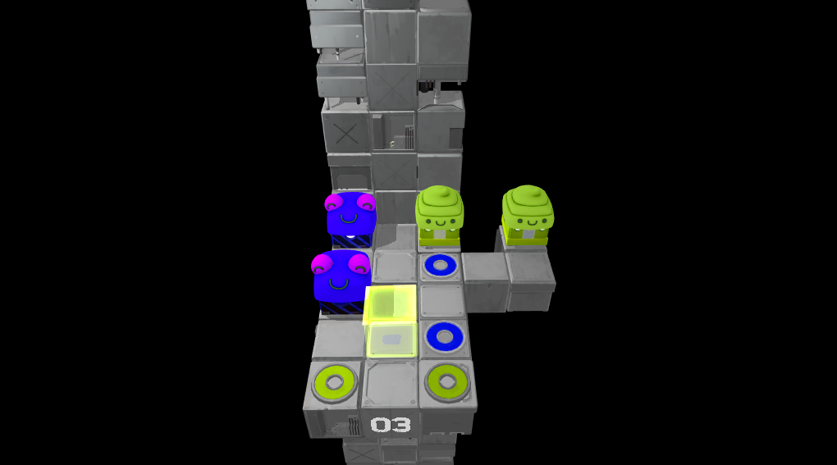
Level 3 Version 1: Designed so players will need to weave between each other, utilising both the gap between the two blue players and the two green players in order to solve the puzzle.

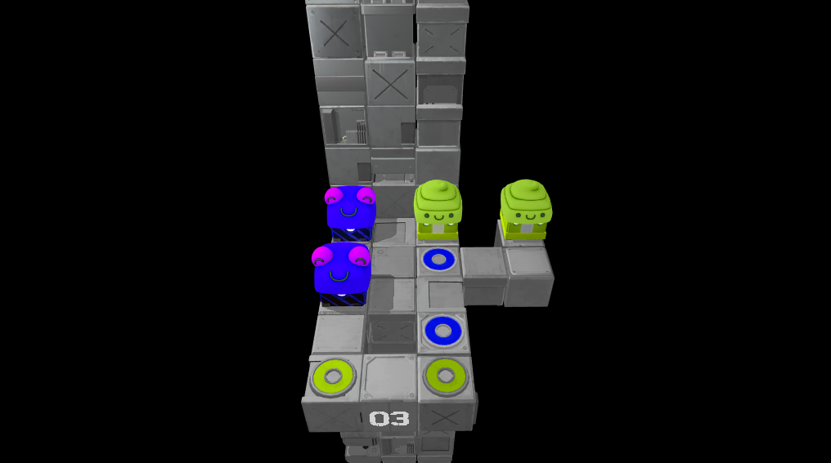
Level 3 Version 2: The Green Holocube was originally placed there to stop the blue player from passing through that square, to force the player to engage with the puzzle concept of weaving between the two gaps. However the green player doesn’t need to pass through that square to solve the puzzle either, so I just removed it entirely. The green holocube was creating unnecessary noise and may lead players to think that they need to pass through it with the green player to solve the problem, so I replaced it with a hole in the floor that accomplishes the desired effect more effectively.
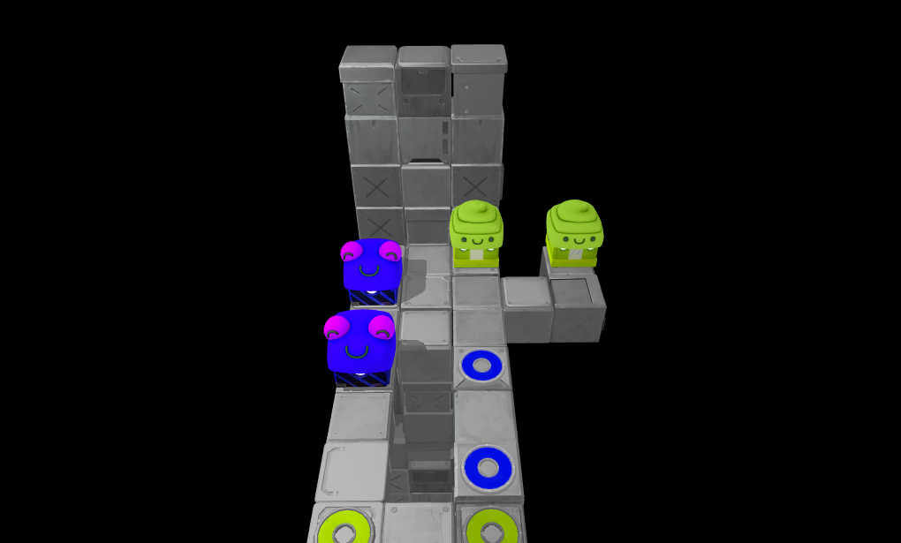
Level 3 Version 3: The addition of the gap in the floor meant the player was able to “accidentally” solve the puzzle by taking advantage of the physics system to skip over the gap by cutting corners. To solve this, I have made the gap much bigger so it is very clear that the player cannot attempt to move the blue players either side of the gap without dying. This has now meant that the camera angle probably needs to be changed, but I haven’t learnt how to do that yet.
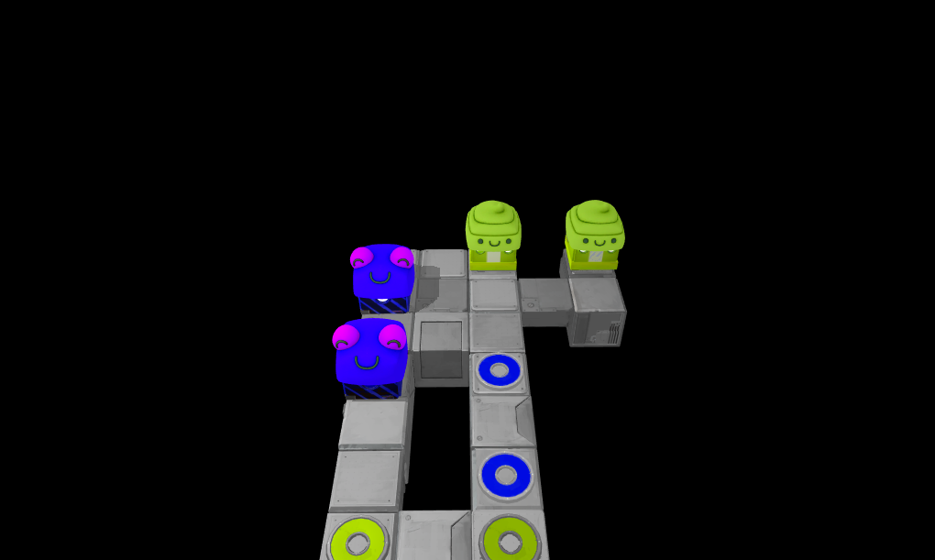
Level 3 Version 4: Removed the back wall so the gap was more salient.

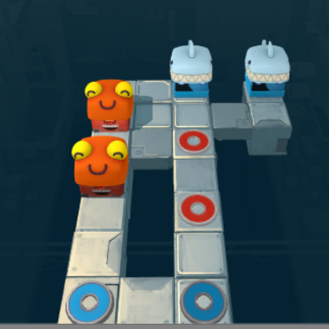
Level 3 Version 5: Moved the red goals up a space so that when the blue players go to their goals one of them isn’t occluding to the bottom red goal (this caused confusion in playtesting).

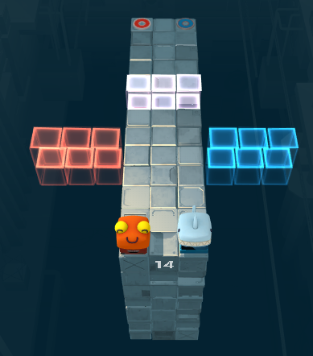
Level 4 Version 1: The purpose of this level is to showcase the different ways in which the holocube mechanic can be utilised (i.e. as a “wall” or as a “floor”), because this has proven confusing to players when testing. Many levels after this use holocubes in various ways (especially the holocube maze levels!), so it’s important to establish how the work early on like this.
The first set of holocubes are “walls”, and move left and right as the players move back and forth. If the players both move forward at once they will be blocked by the holocubes – they need to go one at a time and phase through their own colours, and this will hopefully help the player clearly realise which players can go through what walls. The second set are meant to be used as floors, going up and down as the players move back and forth. The player needs to position one player so that that colour holocubes provides a floor for the other player. However, the holocubes over the top of each other like this blend in a confusing way, because of how transparent they are, and I’m unsure if the second half of this puzzle will be very legible or teach the player much. This is especially true because it doesn’t give the players a chance to fall through the floor of their same colour, which is an important aspect of using holocubes as floors.

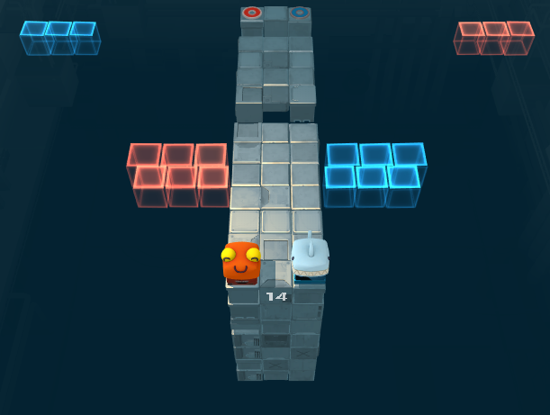
Level 4 Version 2: I made the second set of holocubes have a larger sin range so that the different colours would be more distinguishable from each other due to being further apart at times. I also added a third set of holocubes that gradually come closer to the middle as the players get further to the end. This requires the players to both be right near that gap before either can cross it, and provides an opportunity for players to fall through the floor if they do it wrong, as was mentioned above.

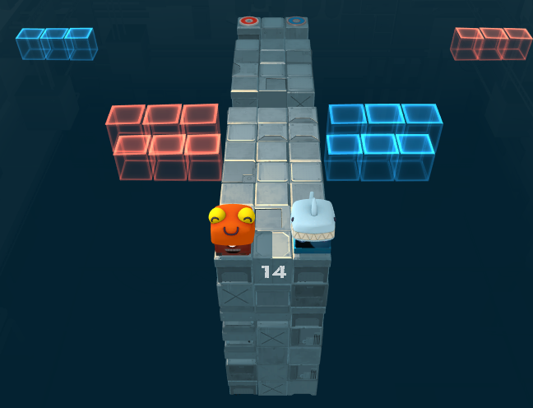
Level 4 Version 3: I lowered the camera so that it is now easier to glean the height of the second set of holocubes.

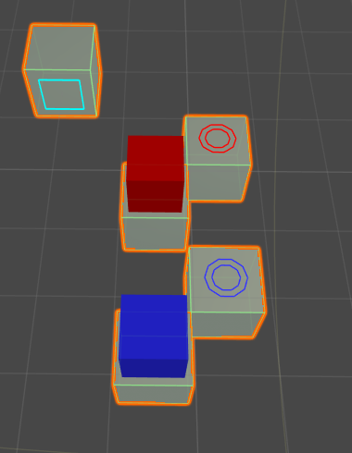
Level 5 Version 1: The game lets the player sneak around corners and past gaps using physics, so I thought this should be taught to the player with specific levels dedicated to it. This draft is the simplest possible version of cutting corners to get to the goal, so it should communicate the idea. However – it is boring! The solution is obvious, the execution is easy, and there is no interaction between the players (which is one of the core features of the game).
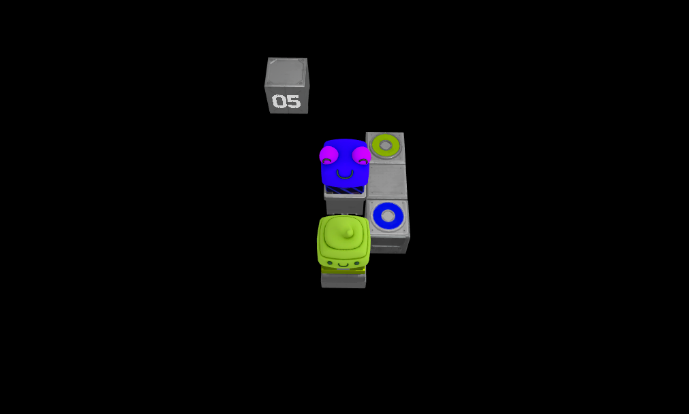
Level 5 Version 2: This maintains a lot of the simplicity and elegance of the previous version while forcing the players to manoeuvre around each other. However, the blue player can just stand still while the green player goes past without cutting corners, so it doesn’t actually represent the point of the puzzle.

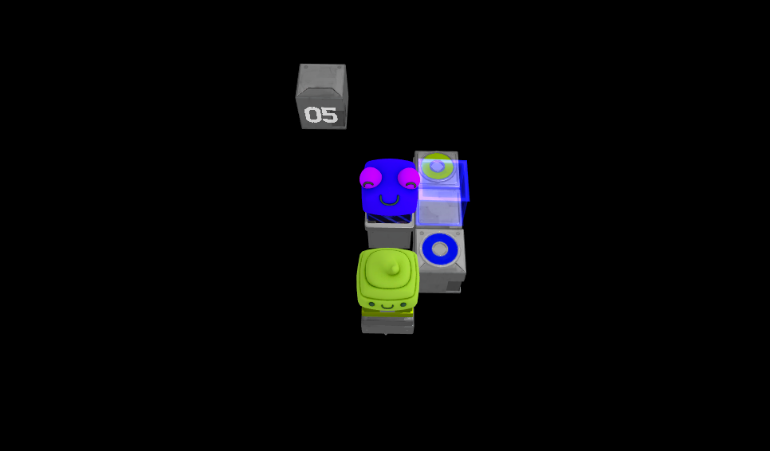
Level 5 Version 3: This holocube means the player can no longer solve the puzzle in the unintentional way, but also that they can’t solve it at all, so that’s a pretty big flaw I think.

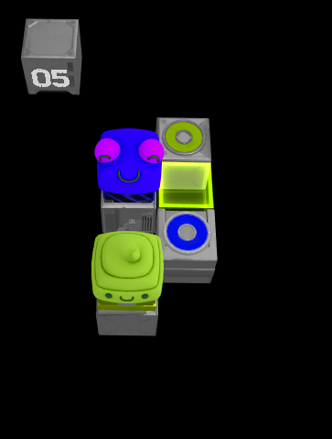
Level 5 Version 4: The previous version’s holocube blocked the green player from crossing the space next to where the blue player spawns, but also prevented it from cutting corners to where it needs to go. I replaced it with a green holocube as a floor gap the green player can fall through. This means the green player still can’t step there, but can still cut corners near it, making the level solvable again. It might be worth showing the player that they cannot skip corners if there is a wall blocking them (like in version 3) in one of the levels, although this level kinda does this.

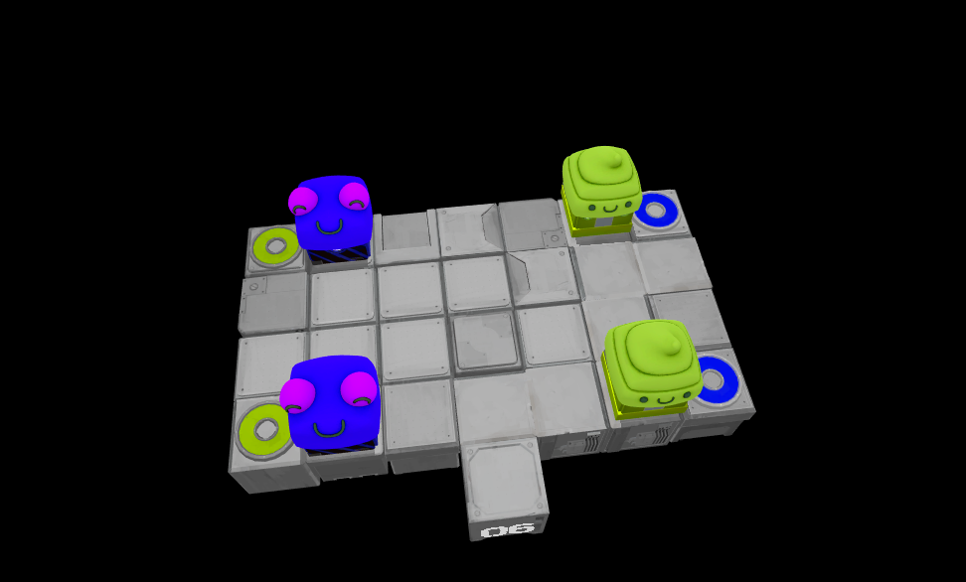
Level 6 Version 1: This level is an attempt to fulfill the solution sentence “Two pairs of robots need to weave between each other by cutting corners”. This can be solved using this solution sentence, but that’s not the only way to solve it, so something needs to change.

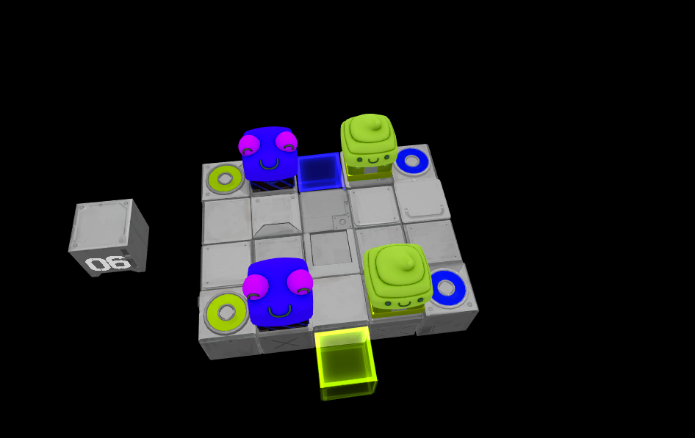
Level 6 Version 2: I removed two unnecessary columns of floor to make the level more compact, and replaced some parts of the floor with holocubes so that the blue player must move diagonally in order to complete the level. This is better, but it would be more interesting if the green player had to cut corners as well.

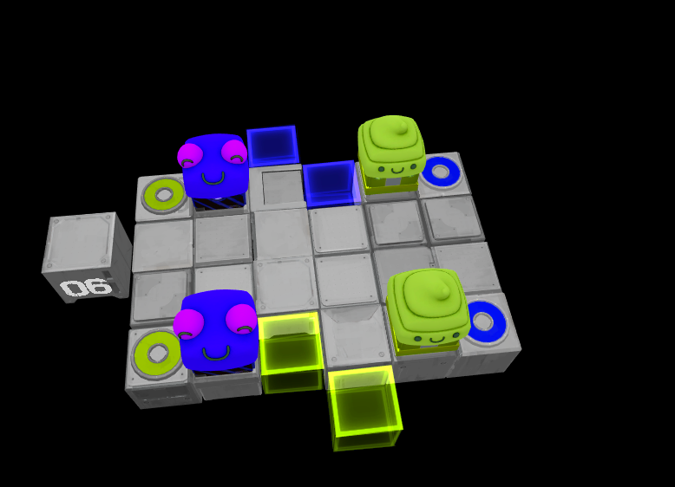
Level 6 Version 3: I added another floor column with some more holocube gaps, which will now get the green player to also travel diagonally. This simple change has instantly made the level much more interesting to play.

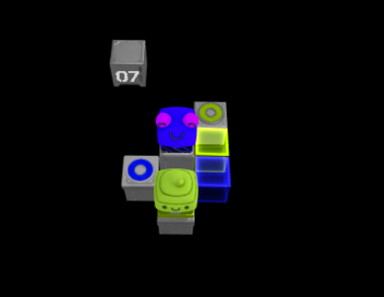
Level 7 Version 1: Looking at the results of Level 6 Version 3, I noticed how much better it was to have both the players interact with the diagonal movement, so I thought it would be a good idea to give the same treatment to level 5. So I copied level 5, and moved the blue goal to the left and added a blue holocube where the blue goal was. I was hoping this would make the blue player have to cut a corner the way the green player does, but this did not work. It made the puzzle much more straightforward because it meant the blue player could move straight to its goal. What needs to happen is the green player is somehow forced to move away from the corner the blue player is trying to cut, like happens vice versa in level 5. In order for that to happen, the player needs to be on the corner at some point. In this version of the level, neither need to do that, which is bad.

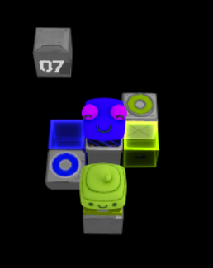
Level 7 Version 2: In moving blocks around to try to get the desired effect mentioned above, I stumbled across this shape, and wondered if it was possible to complete. It is, by moving very carefully. This is a unique solution that is different from what I’m going for with level 7, so I think I will reuse this idea for a different level.

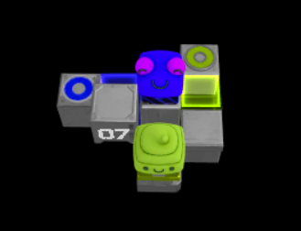
Level 7 Version 3: I realised the only way to ensure there was a green player on the blue holocube that the blue player had to go around (after the green player had just done the same thing vice versa) was to have a moving block that ensured the green player was in a certain spot before the blue player got there. So, in this image, the block with the “07” on it moves down as the green player moves left, only allowing the blue player to access it when the green player is on the blue holocube. However, the only way for the blue player to move out of the road from there is to move to the right, which changes the height of the block again. This change in height means the blue player has to jump down from the block rather than just diagonally across, which is an unnecessary layer that further complicates an already tricky puzzle. I will have to change this somehow.
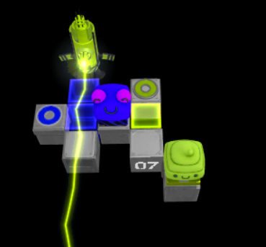
Level 7 Version 4: I have gotten rid of the moving block because of the issues mentioned above, and instead forced the green player to move to the blue holocube. This accomplishes the same purpose as the moving block but much more cleanly. I think this achieves the desired goal that I set out for this level, but I have one more small detail in mind to spice it up.

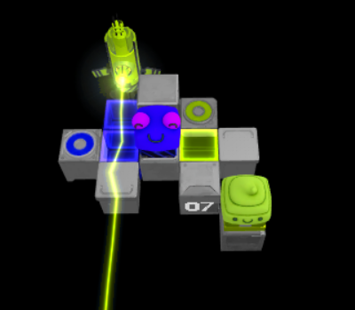
Level 7 Version 5: I’ve put a wall blocking the green player from going diagonally onto the far holocube, thereby forcing them onto the near holocube first, and then move to the other holocube. In theory, I’m hoping this will help reinforce the edge case concept that a player or wall on a corner will stop a player from cutting that corner. Just putting the wall there would stop the green player from reaching its goal, so I added an extra block for it to move on at the far right.

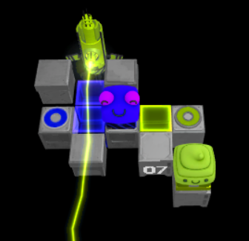
Level 7 Version 6: I realised that having both the block on the right and the green goal space didn’t add anything to the puzzle, so I made them both the same (i.e. moved the goal block to the spot on the right). I also added another wall next to the spot near the laser, for the same reason as in Version 5.

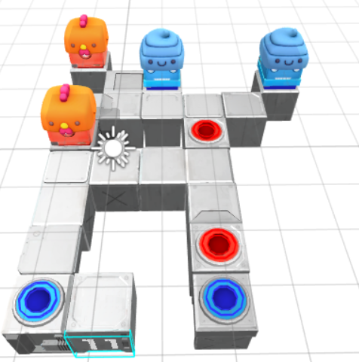
Level 8 Version 1: This level is an attempt to fulfill the solution sentence “Two pairs of robots need to weave between each other by cutting corners (one split vertically, the other horizontally)”. Basically, recreating Level 3 but with the diagonal movement of Level 6 as an extra twist. This does involve the players weaving between each other, and also a lot of cutting corners, but only the orange players need to weave between the blue players by cutting corners – the blue players don’t weave between the orange players by cutting corners.
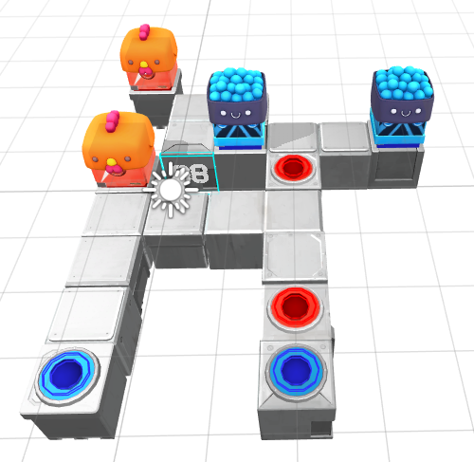
Level 8 Version 2: I removed the block in between the two red players that allowed the blue players to weave between them without moving diagonally, and changed where the blue players spawn so they don’t have to move diagonally at the very start. It would be possible to add more diagonal movement to this level, but I think that would just add tedium and not contribute to the puzzle.

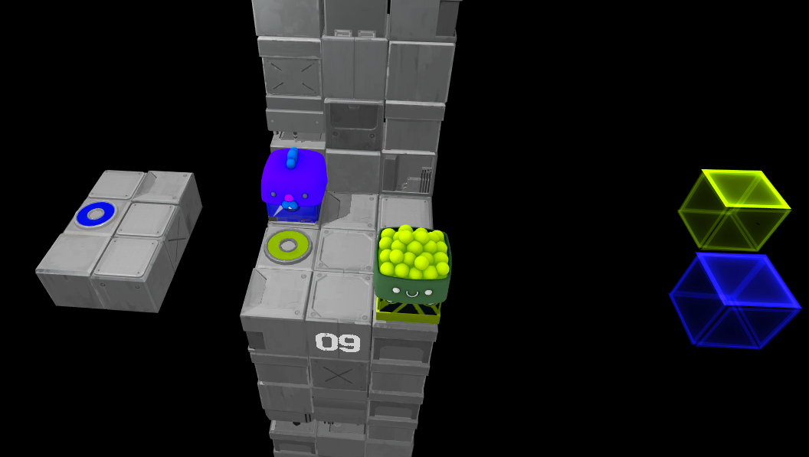
Level 9 Version 1: In this level, the green holocube moves three spaces to the left for every one space the green player moves, which means the green player can send it at high speeds into the blue player, sending the blue player over the gap to the platform with the blue goal. Unfortunately, it is very difficult for the player to get the timing right due to the physics of how both the players move.

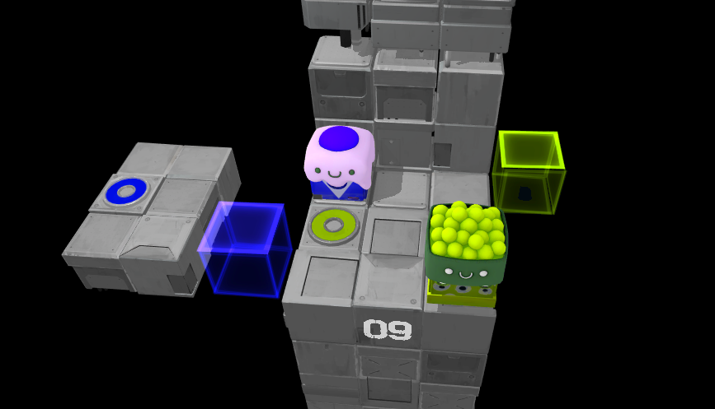
Level 9 Version 2: I updated it so that the holocube movements are now triggered by the goal spaces rather than being tied to the players’ position axis. This gives me a lot more control over the speed, position, and acceleration curves of the holocubes’ movement. The physics can still be a little bit unpredictable, and its not clear to the player if they are always going to make that gap.

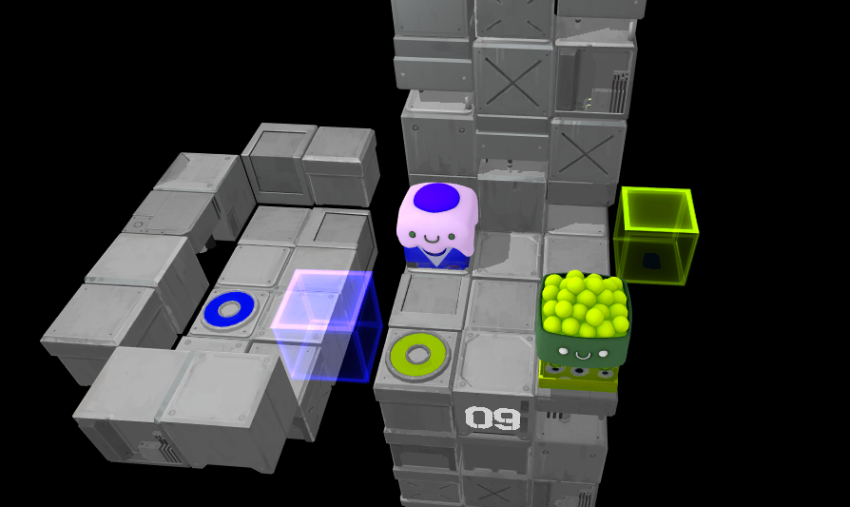
Level 9 Version 3: I made the gap smaller and gave the other platform walls to make it less likely for the blue player to miss. I also moved the green goal one block closer to the camera, so that the green player’s collision won’t interfere with the blue player’s trajectory when the green goal is activated. This does have the bizarre side-effect of the green player being pushed off the edge when the blue goal is activated, although I think this situation of winning the level and then immediately going flying into the void could prove humorous for players, so I’m going to leave it in for now.

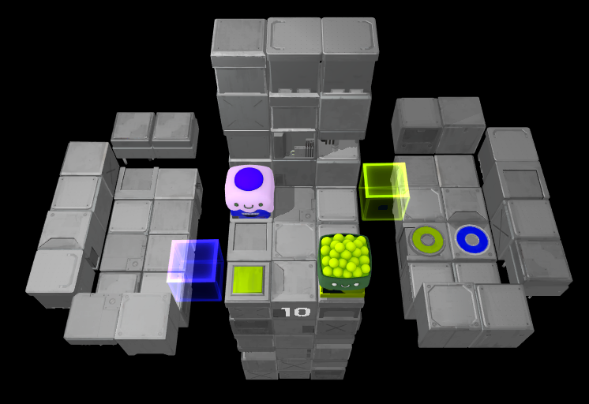
Level 10 Version 1: This expands on the idea presented in Level 9 by requiring the blue player to be launched by the green holocube on its way back to its start point instead. It also utilises the green player being launched by the blue holocube, and introduces the pressure plate mechanic to the player. The platform to the left is not used in the puzzles solution, but rather provides noise, a misdirection made more interesting and effective by the context of the previous level, in which the left platform was essential to beating the level. The purpose of misdirections like this in my levels is to ensure that the player is intentional and thoughtful about their approach to solving the puzzle, which generally makes for a more satisfying puzzle experience. This level seems good for now, but the physics are still proving to be unpredictable, so I might avoid using this launch mechanic in too many future levels.
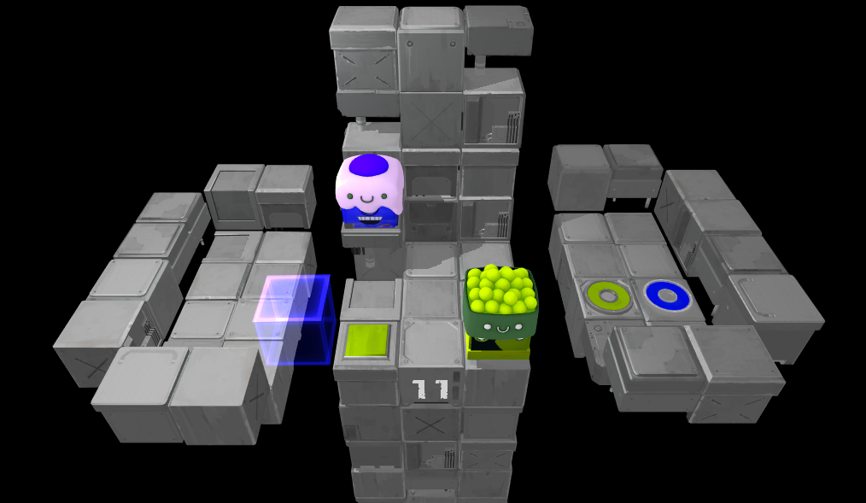
Level 11 Version 1: This is very similar to Level 10 in actual structure, but with no green holocube, with the blue player spawning a block higher, and with the blue holocube triggered by the green pressure plate. These subtle changes were made to create a very different solution, that involves both players being launched at once, with one atop the other. However the physics of the launch can vary, so this is probably the last level I will make involving the launch mechanic.

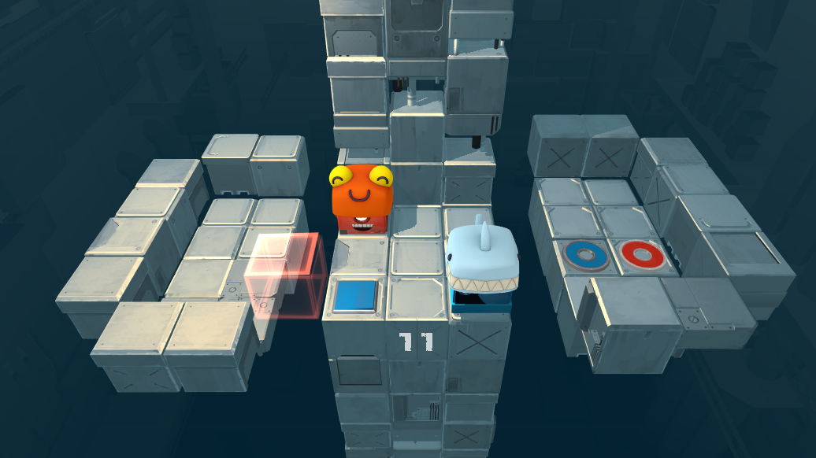
Level 11 Version 2: It turns out that getting the players to launch while on top of each other properly was extremely inconsistent, but I also realised that the level can be solved by moving the red player two blocks to the right of the blue pressure plate an then moving the blue player onto the plate.

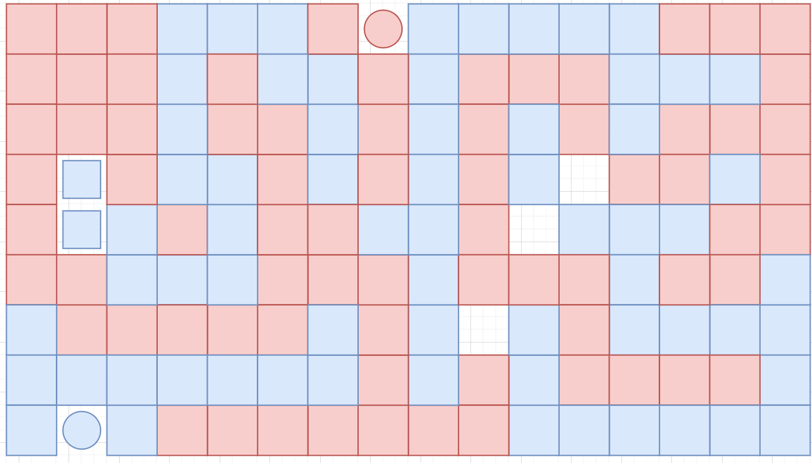
Level 12 Maze Diagram: I used this diagram to help prove to myself that a maze level could be possible and interesting. This served its purpose for me, but doesn’t communicate much without context. So for the sake of this document I will clarify that I plan on having the players start to the right of the maze, with the big squares representing holocubes making up a path for each player to traverse, the small blue squares representing blue pressure plates that will raise up a block allowing the players to walk on top of holocubes. This is difficult to explain in words, and since I am the only one using the diagram and it makes enough sense to me (because the rest of the context resides in my head), I’m going to leave it there and start making the level itself in engine.

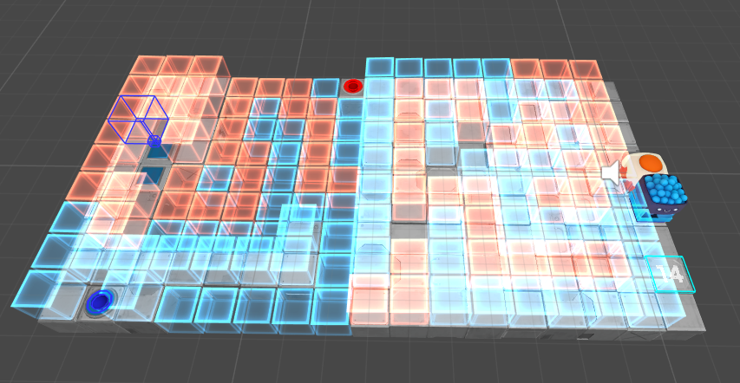
Level 12 Version 1: After making the level in engine the thing I immediately noticed was how ugly and difficult to visually parse this level was with all the transparency. It would be nice to find a solution to this, but it may be inherent to the level’s concept due to the way holocubes work.
To complete the first half of the maze, the blue player must follow the blue path and the red player must follow the red path, because the cubes can only move through their own colour’s walls. In the second half of the maze, however, the holocubes are floors, which means they will fall through their own colour and die. Thus the roles are reversed in the second half – the blue player follows the red path and vice versa. Both players need to make it to the blue pressure plates, so that they can use the raising block to put the red player on top of the blue player. Once the blue player has carried the red player to the red goal using the red floor path, the blue player needs to use the raising block to get on top of the red wall path to get to its own goal. However, with the way the path is now it turns out it can’t actually get next to the raising block without triggering it first, so a small adjustment will need to be made.

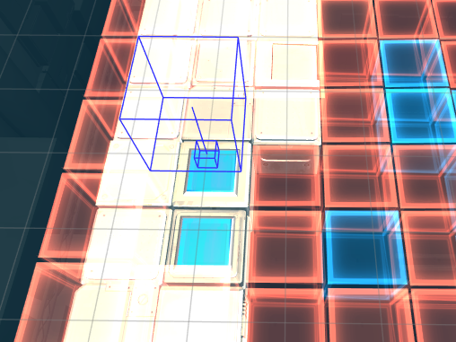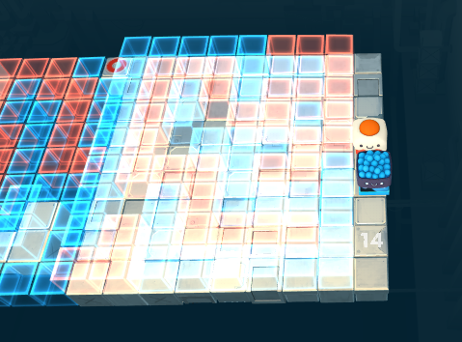
Level 12 Version 2: I made the small adjustment mentioned above (first image), and improved the camera angle (second image). The camera angle has made things slightly more legible, but not enough, so something will have to change with the lighting.

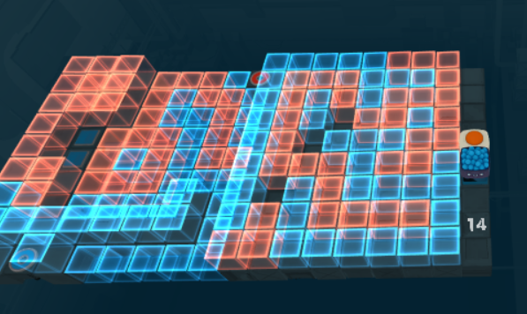
Level 12 Version 3: Luckily, simply turning off the lights has made a massive difference to the salience and clarity of the holocubes. However, it does make it much harder to tell where there is floor and where there are gaps (although the height difference between holocubes is still clear, which is good). The other issue that this causes is the blue pressure plates and player goals are much less salient.

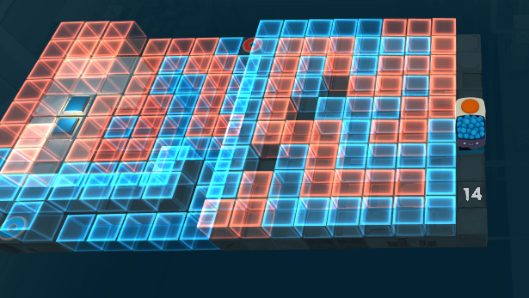
Level 12 Version 4: I have placed a smaller point light over the goals and the pressure plates. This has made is very clear that there is ground near the pressure plates and no ground to the right of them. For some reason the lighting is significantly more noticeable for the pressure plates than the goals, which I’m theorising is because there is more solid ground nearby for the light to reflect off of. After some external playtesting, it is clear that being able to discern between the colours of the blocks is the number one priority.

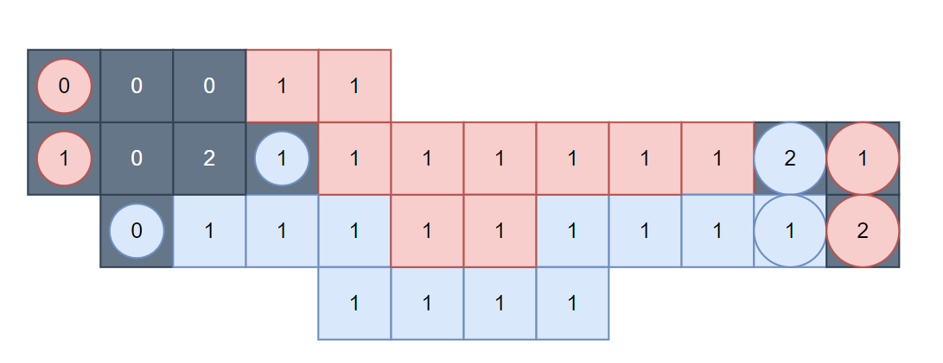
Level 13 Diagram 1: The synopsis/solution sentence I planned for this level is “Two pairs of players with half of each pair on top of a holocube maze, and the other half within the holocube maze”. This clearly needed planning with a diagram before I could put it in engine, but since verticality was such a crucial part of this concept, I needed to represent 3 dimensions in a 2D diagram. To accomplish this, I used numbers on each space to represent the relative height of each element (with the assumption that all holocubes have a regular floor below them that isn’t represented here). The dark grey squares represent regular walls/floors, the coloured squares represent holocubes, the large circles represent player spawn points, and the small circles represent goal spaces. The player needs to step through the maze with the blue players, and then with the red players. The red players will need to go through the same paths but using slightly different moves due to the heights being reversed compared to the blue players. The intended solution is then to use the bottom blue player to carry one of the red players forward so that they can both get on their goals at the same time. I added this last section to ensure that the different coloured players had to interact with each other in a meaningful way, which I believe is crucial to this game’s experience.

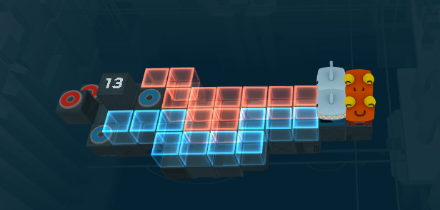
Level 13 Version 1: This draft is exactly the same as the diagram above, with the exception of the all players starting at a higher level, because I quickly realised they would get stuck immediately if using their heights from the diagram. When testing this level, the first problem I noticed was that the blue players are positioned on the left but use the right stick, which is unecessarily counter intuitive. The second issue I noticed was that at the end of the path the blue players end up two spaces away from each other, which makes it impossible for them to both be on their goals at the same time. The next iteration will attempt to rectify these two problems.

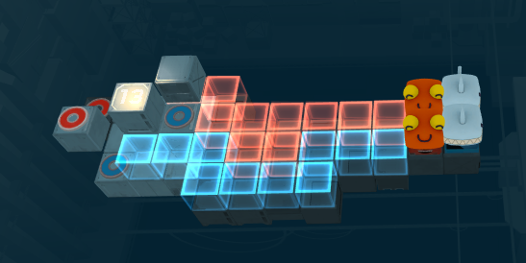
Level 13 Version 2: I switched the red and the blue around, which not only fixed the control issue mentioned, but also meant that the red players must now go first, which makes for a more interesting solution since that means the blue players have to sneak past them in order to carry one later. I also added a block behind the top blue goal so that the blue players can make themselves closer together by pushing against it. This has meant that the level is now solvable, although when carrying out the solution the top blue player does stay squarely on their goal, which may confuse players and have them think that that is not the intended solution. Finally, I added some lighting so the ground wasn’t as dark, but where I put it caused the level number to become illegible.

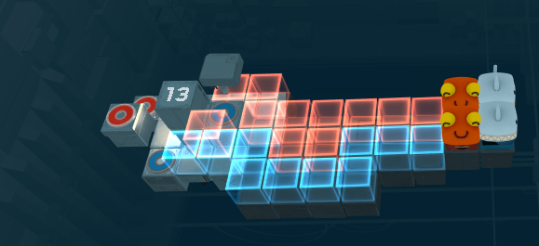
Level 13 Version 3: I added a red holocube in front of the blue goal space to prevent the player from slipping off it, and moved the point lights around to improve the lighting. The only other issue I have noticed with this level is players getting caught on corners making the pairs no longer synced up, which unfortunately may be inherent to how pairs function within the physics system of this game.

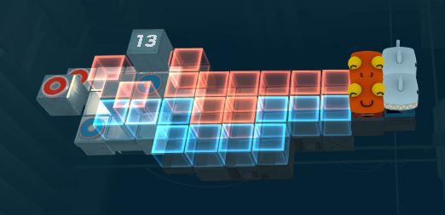
Level 13 Version 4: I replaced the block left of the top blue goal with a red holocube, so that the top red player will not get caught on it.

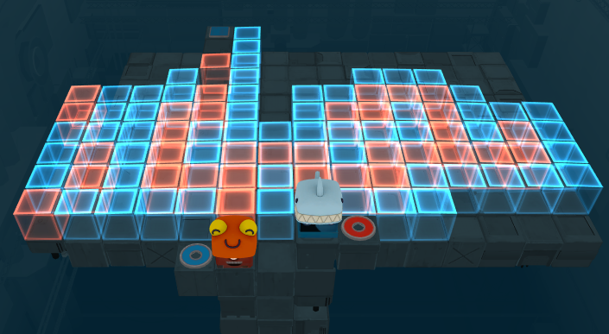
Level 14 Version 1: This level’s solution sentence is “One player moves along the top of a holocube maze, the other along the bottom, and they need to swap when they get to the end and then go back through the maze on the other layer.” I’m noticing these solution sentences are getting quite long and unwieldy, which might be a sign that I’m not sticking to the simplicity I was designing with in the earlier levels. However, I still like this level concept and think it is a natural extension of the holocube maze idea introduced in the previous two levels. I will try to return to simple solution sentences in future levels, which should be easier once I start introducing new mechanics and combining them together.
I wanted to test myself and make a holocube maze without first mapping it out in a diagram. This has likely saved me a bit of time, but has meant this first version of the level is clearly unfinished. The paths are there, but the “noise” of the puzzle (in this case paths that lead nowhere to misdirect the player) is lacking, which makes for a pretty uninteresting maze. I was also so focused on designing the maze as I was making it, that I forgot to add any lighting. Nonetheless, this first draft has proved the solution sentence as valid for making a puzzle with.

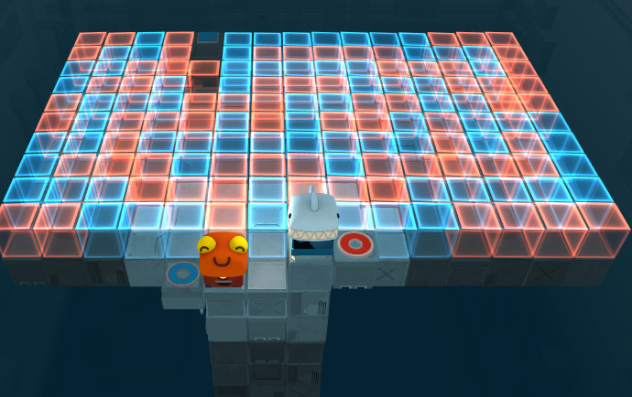
Level 14 Version 2: In this version the maze is much more filled out and requires more attention to find the paths through. The lighting has also been improved, although despite putting a point light there the pressure plate at the end is still difficult to see.
After some more experimenting with the lighting, I have realised that the game seems to only support one source of light per level, at least when it comes to lighting up the floor. I don’t have a quick solution to this when it comes to the holocube mazes, as having one big top light as usual makes them unintelligible (see Level 12 Version 1).

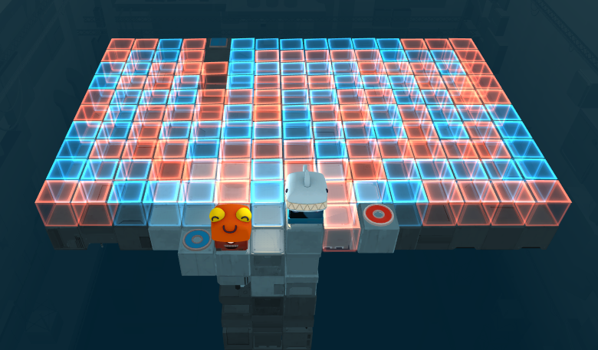
Level 14 Version 3: The intended solution is to get to the end of the maze with both players following one red path, lift the red player up with the pressure plate and drop the blue player down, and then take separate blue paths back to the beginning. However, in previous versions the blue player could carry the red player all the way back to the start and it could reach the goal from that. I have put a red holocube between the blue player’s spawning point and the red goal, which means if the red player tries to do this now the will fall through the holocube and die.
This has the added bonus of showing the blue player where to start their path, as in previous iterations the blue player was blocking the first red holocube it was meant to move onto from the camera’s view.

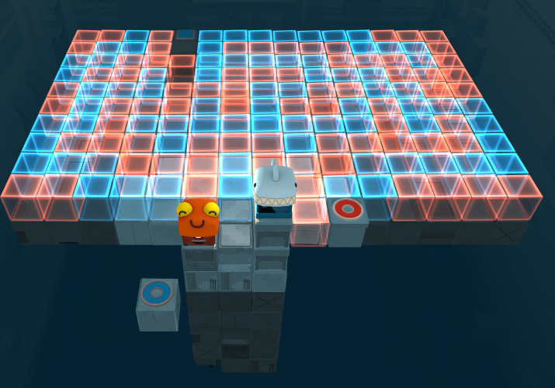
Level 14 Version 4: I realised that since goal spaces also trigger things triggered by pressure plates, the blue player didn’t actually need to move through the maze to solve the puzzle because they could access the goal space from the very beginning and use it to move the red player up. To fix this, I made it so the blue goal space is not attached to the rest of the level floor, and only moves over once the red player lands on its goal.

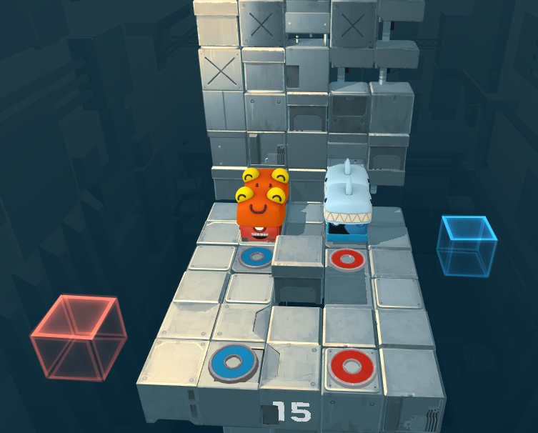
Level 15 Version 1: I want to make a level that fulfills the solution sentence “Split up the two pairs so they can weave between each other.” To do a quick prototype of what this might look like I copied Level 2, made the players start next to each other and put a raised block in the middle for them to push against in order to separate the pairs. I also needed to make the gap between the goals bigger because it turns out they can still somehow trigger both goals when next to each other even when the goals have an empty block between them.
This version is solvable, but doesn’t require any weaving between players.

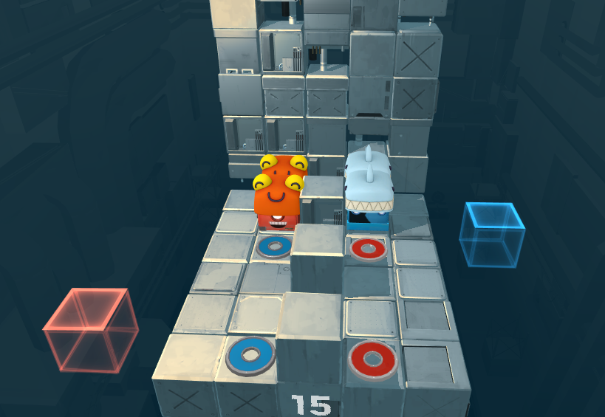
Level 15 Version 2: With the addition of more blocks down the middle, there is now no way for a pair to go through the middle without splitting up first. However, there is enough room one pair can go around the other while they are both split, so still weaving is not required.

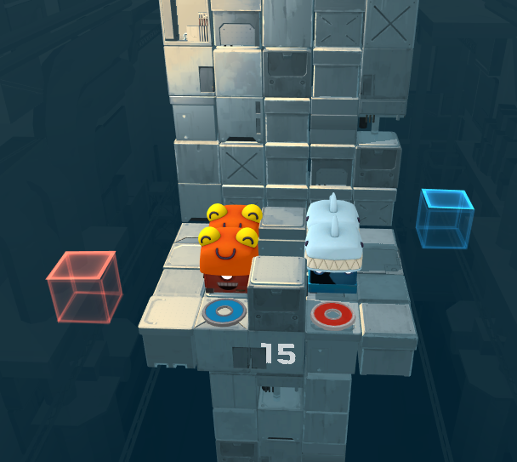
Level 15 Version 3: I reduced the amount of space the players had to work with, and now I am not aware of a way they can beat this level without weaving through each other. I am a bit concerned about the fact that the player now needs to beat the level with only one gap between the players of a given pair, while there are two gaps between the goals of the same colour. This is very easily possible, but may feel wrong for the players, or even feel like they didn’t complete the puzzle “properly”.

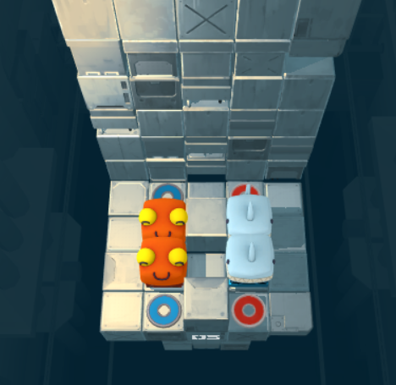
Level 15 Version 4: In playtesting, the moving holocubes confused players with unnecessary noise. This is supposed to be a simple puzzle, but the holocubes added complexity and weren’t part of the solution, so I removed them.
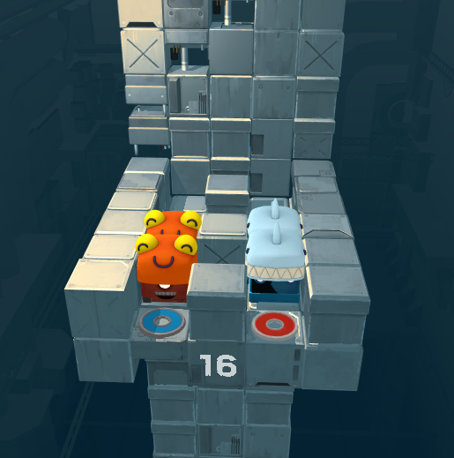
Level 16 Version 1: In developing Level 15 I realised it could be interesting to make one pair make itself even wider in order to swap sides, and then use the back wall to bring them closer in order to reach the goals. This first draft has the space and side walls that allow this to be possible, but it’s far from the only way to solve this puzzle, so more limitations need to be implemented here.

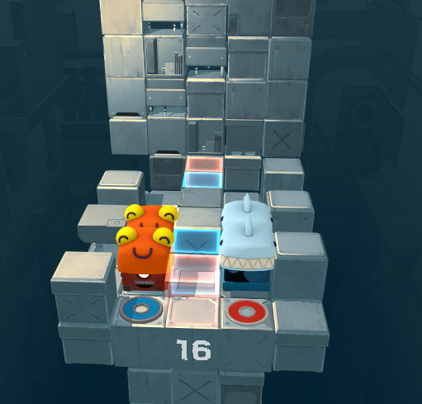
Level 16 Version 2: There are now holocubes that dictate which pairs can go through which gaps. However, there is still nothing stopping both members of a pair from going through the same gap, which means splitting is still not necessary. I think the best way to make splitting necessary will be through the threat of death in the form of holocube floors.

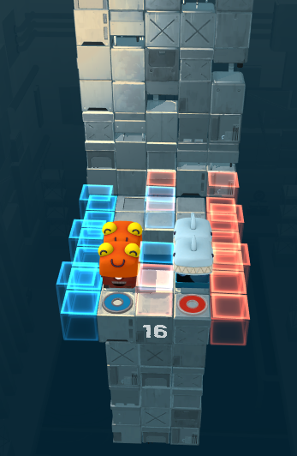
Level 16 Version 3: Just as I hoped, these holocubes make it virtually impossible to get both members of a pair through the same gap. Using the holocubes I made it so the players can only interact with the walls on their side, and will phase through the walls on the opposite side, so that the player is forced to get the spacing right before crossing the middle. This fulfills what I intended for the level, the only problem I still have is that actually executing the solution is a bit finicky.

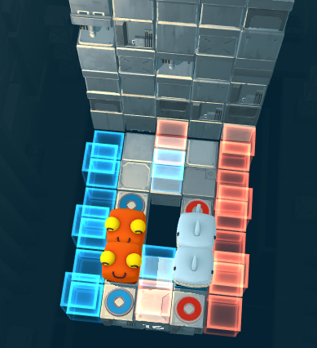
Level 16 Version 4: A change in camera angle has made navigating the tight grid of this level much more manageable.

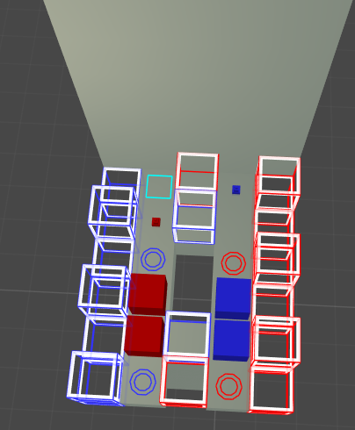
Level 16 Version 5: I added some spikes that would make players kill each other if they didn’t carefully get onto their goals in the right formation. The reason I did this is that this level didn’t really have a clear way for players to kill each other, and I think accidentally killing each other is an important part of this game.

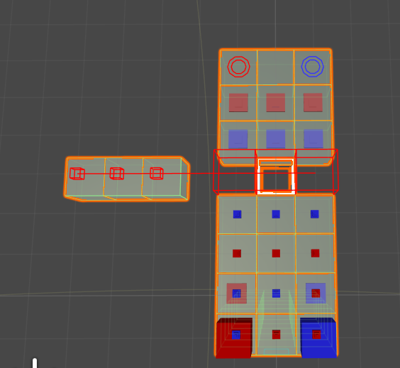
Level 17 Version 1: This is the introduction to spikes, essentially a floor full of spikes and pressure plates and the players just need to avoid killing each other as they move forward. I added mandatory moving platforms so the players had a reason to step on pressure plates. I thought this level would be too basic, so I tried to add lots of spikes to increase complexity, but this ended up making it legitimately difficult and even impossible. I underestimated the trickiness of spikes, so this level definitely needs a redesign.

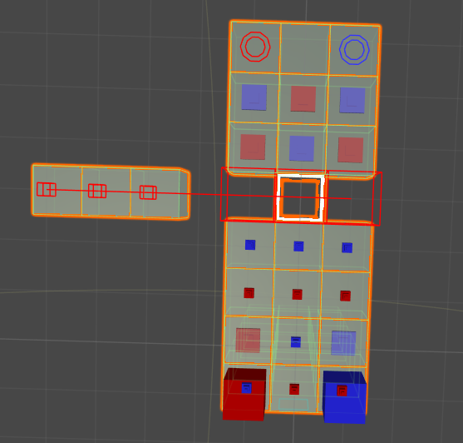
Level 17 Version 2: I switched up the pressure plates in the second half so that the blue player can get off the bridge without killing the red player.

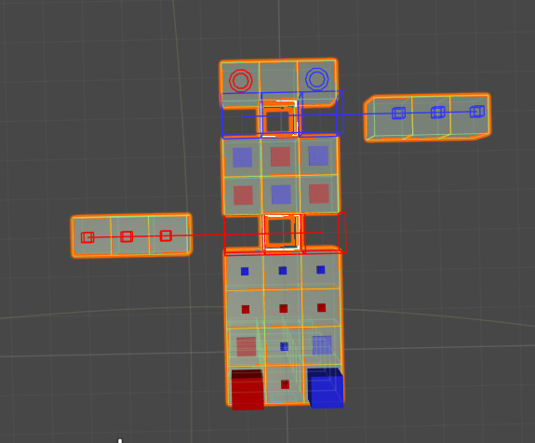
Level 17 Version 3: I added another movable bridge, this one triggered by the blue pressure plates. This means there is now also incentive to step on the blue pressure plates. It also means that there is another spike-free block that the blue player can stand on in the form of the holocube, which will make manoeuvring at the end of the level a bit easier.

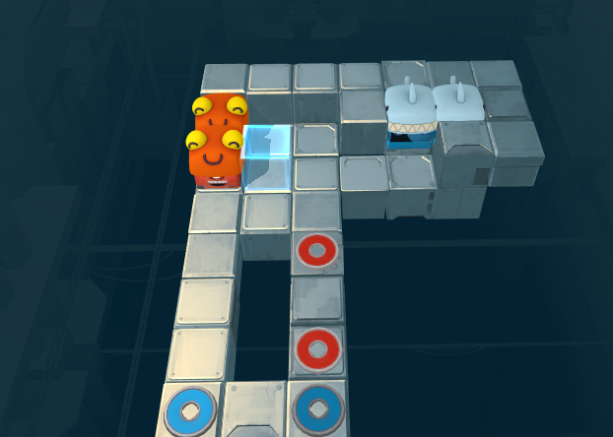
Level 18 Version 1: This is a similar solution to Level 3, but with the added challenge of needing to first split up the pairs like in the previous two levels. The blue players use the various walls around them to split up, and the red players use the blue holocube and parts of the back wall. Surprisingly, the combination of these mechanics works quite seamlessly with no major design flaws I can see even in this first draft. The way the level is spaced out, just like with Level 3, the players have no real way of solving the puzzle without engaging in the intended method.

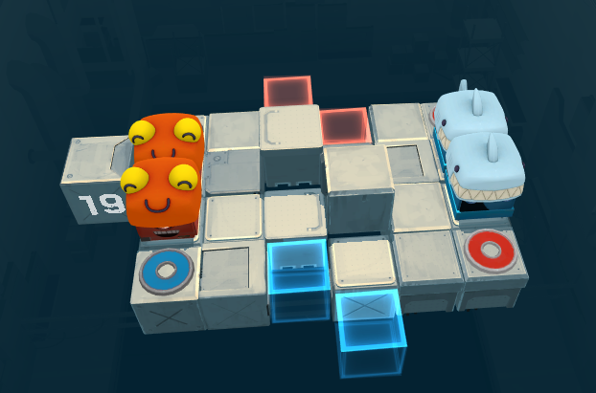Level 19 Version 1: Similarly to the last level, this is a take on an older level with the added twist of needing to split up the pairs. The only changes so far are making the players start next to each other and putting two raising blocks in the middle that both force them to split up to get past, but can also be used to split them up.
At least that was the theory, but in practice these blocks stop both players from progressing even when split up.

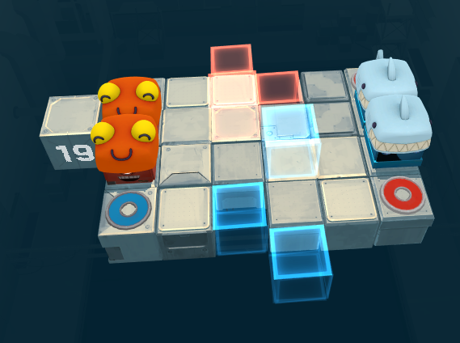
Level 19 Version 2: Replacing the raised blocks with coloured holocubes allows the players to push against them but also lets the right players past when needed. This means the puzzle is now completable and requires splitting up. The only problem is that it doesn’t require diagonal movement from both players, as there is just enough leeway for players to split up far enough to reach the goals but not far enough that they can’t just sneak past in a straight line.

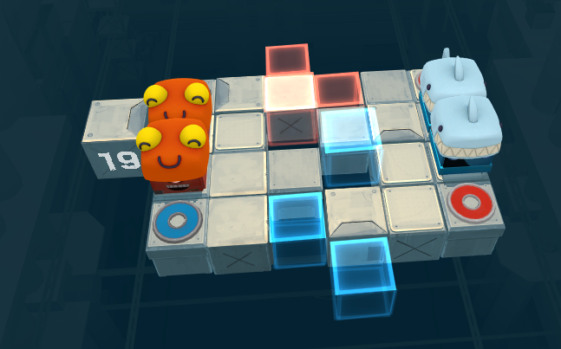
Level 19 Version 3: Removing the floor below the holocubes means the players need to split up further to get past, but what I failed to account for is that in splitting up further they will have no way of lining up vertically again. They will end up like this: 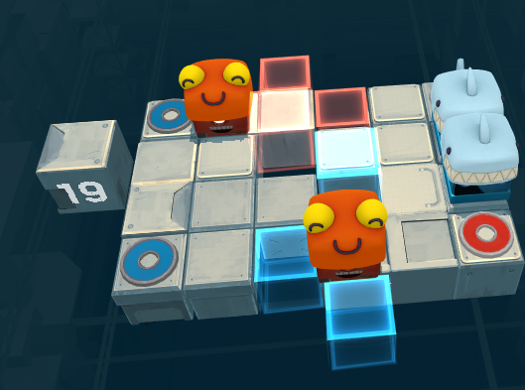
It is impossible to move the far red player to the right without moving the near one, because that would require pushing right against the blue holocube, which would require moving forwards, which would send the far player off the edge.
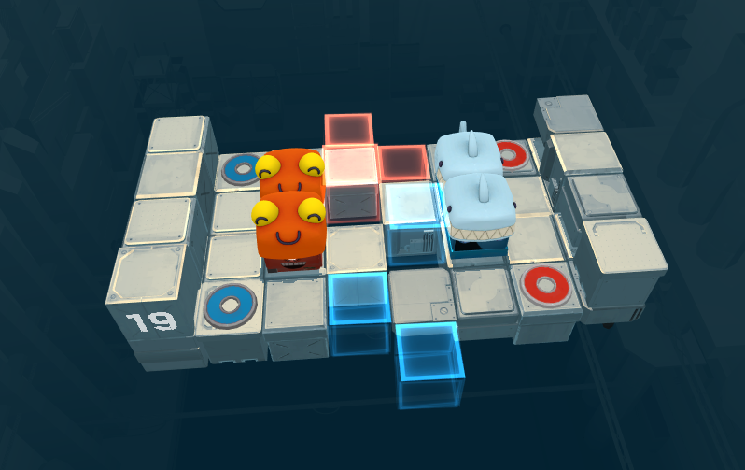
Level 19 Version 4: I added walls on the sides to allow players to push up against them in order to align the pairs vertically again. I also moved the spawn points inwards so that the goal spaces are visible from the start of the level.

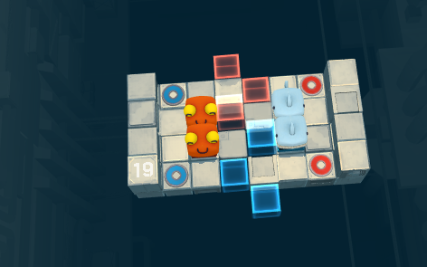
Level 19 Version 5: I moved the camera up so the player can more easily see how all the holocubes are positioned.

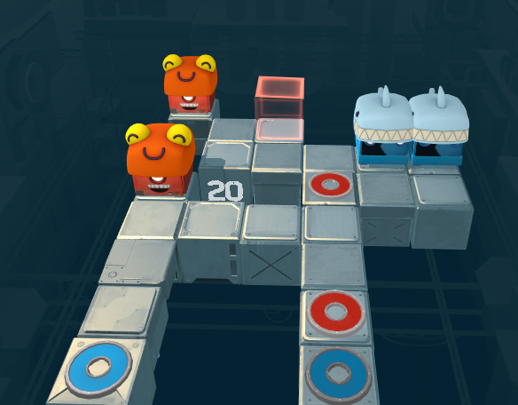
Level 20 Version 1: This level’s solution sentence should be “Split up the two pairs so they can weave between each other by cutting corners (one split vertically, the other horizontally)”. So far, by taking Level 8 and pushing the blue players together, adding a red holocube, and more squares to move on near the blue spawn points, I’ve made the blue player use splitting up as part of the solution, but I’ve not yet done this for the red players.

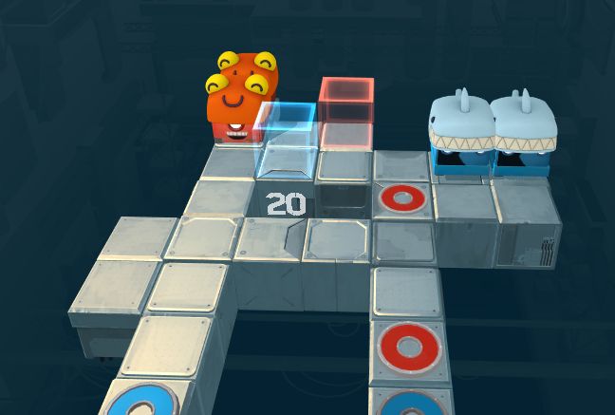
Level 20 Version 2: I performed the same treatment I did to the blue players above on the red players in this version. The level now requires splitting up and is pretty interesting to execute, so this might already be a good puzzle. However, similar to Level 8 Version 1, there is weaving and cutting corners, but the players don’t actually use cutting corners to weave between each other.

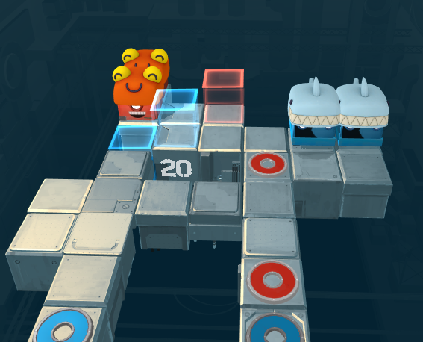
Level 20 Version 3: Since, as mentioned above, the issue was similar to the issue in Level 8 Version 1, the way I fixed it was similar to Level 8 Version 2. In Level 8 Version 2, I removed a block between the red spawn points so that the blue player couldn’t go through there without moving diagonally. I wanted the same effect here but I also needed the red player to be able to step on that block in order to split its pair up, so I simply turned it into a blue holocube, allowing the red player to stand on it but making the blue player fall through it. The other thing Level 8 has that this level doesn’t is that the red players have two diagonally moves in that level and only one here, but this is negligible.

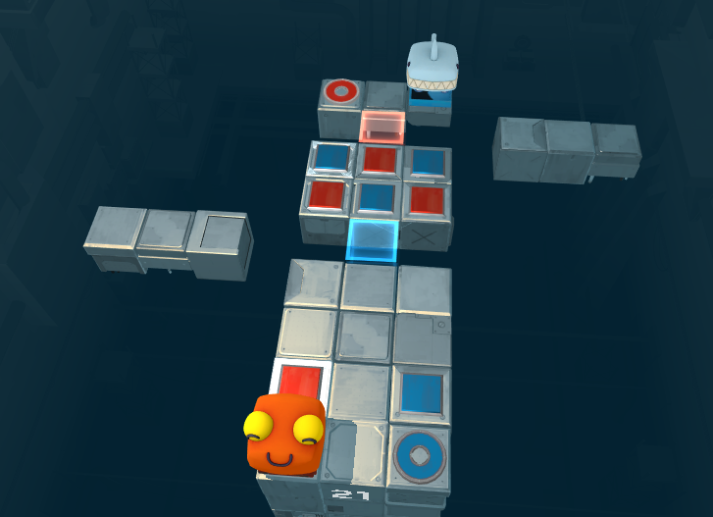
Level 21 Version 1: I thought the quickest way to do a rough prototype of the solution sentence “Players swap positions within a shared spike maze” would be to take Level 17 and swap one of the players with one of the goals. I am also generally interested in how small changes in levels can significantly change the solution, and how that plays with the player’s expectations.
Unfortunately this hasn’t proven to be any more of a challenge for the player than Level 17 already was. I think focusing on the “swapping positions” part of the solution sentence and making challenge in figuring out how to move the players past each other will make the level more unique.

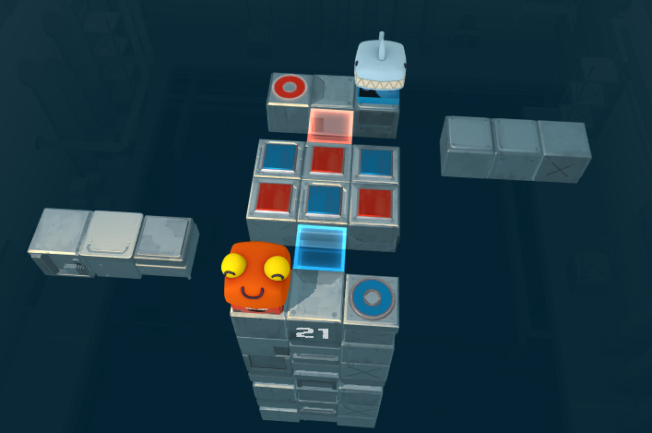
Level 21 Version 2: The big space at the beginning wasn’t necessary like it was in Level 17 when the player was still new to how spikes work, so I removed it and moved the red spawn row closer to the rest of the level. This has already made the level much better, because the players have limited movement options and need to be cautious about how they move past each other in the middle section.

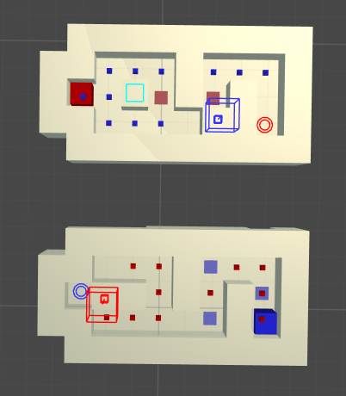
Level 22 Version 1: This level’s solution sentence is “Both players move through their own spike maze with pressure plates in them, each of which affects the other maze.” The player needs to use the pressure plates to open some aspects of the path, and but the pressure plates also activate spikes, so they need to be very careful about their paths and the order they move in.

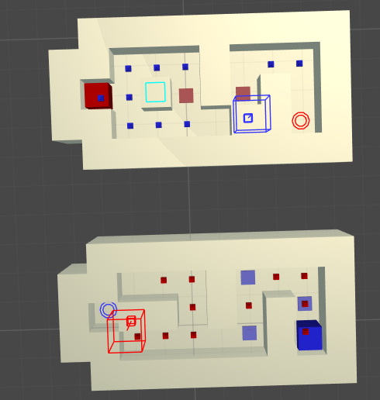
Level 22 Version 2: I removed one of the blue spikes, because it was creating a situation where the players were both on pressure plates and both stuck between spikes, thus soft locking the level.

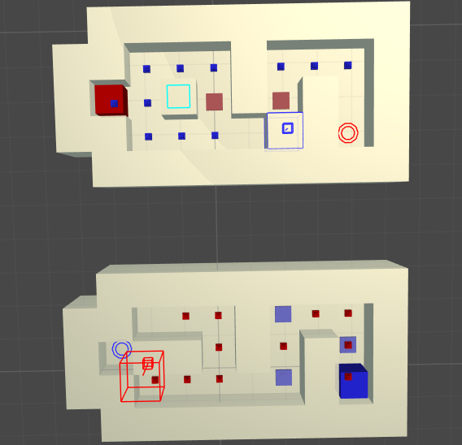
Level 23 Version 1: I mentioned earlier how I enjoy surprising the player with a similar level but with a few small but crucial changes that alter the solution completely. Level 23 is one of those, taking Level 22, putting the blue spike that caused a soft lock back in, and made the block moved by the pressure plate go down instead of up. This might seem pointless, but now the solution sentence is completely different.
Now the red player can’t get to the end of the maze from within because of the spike, but it can get on top of the walls by getting on the moving block when it is down. This is a unique puzzle, with a bit of a “Spot-the-Difference” element to it, as to see the solution the player might need to notice how it has changed from the last level.

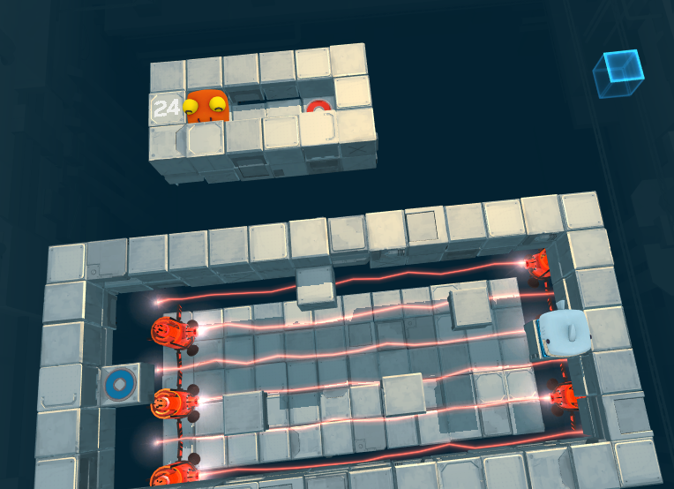
Level 24 Version 1: This level started as a response to the solution sentence “Moving cubes mean player can only deactivate spikes for a second at a time, which means the other player has to time their movement for when the spikes are deactivated.” However, this didn’t work when I realised that pressure plates can’t deactivate spikes, only activate them. So I instead made the red goal trigger a floor that would come up to allow the blue player to walk over a set of lasers below. The red goal also triggers a blue holocube to start flying towards the red player, which will push it off after a couple of seconds. This means that the blue player has limited time to get to the next safe space before the floor goes back down again.

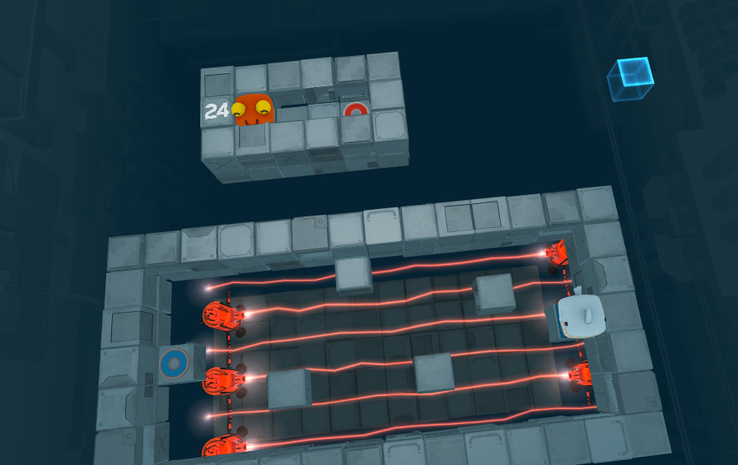
Level 24 Version 2: I updated the lighting to have a stronger contrast between the cubes below and the safe spaces.

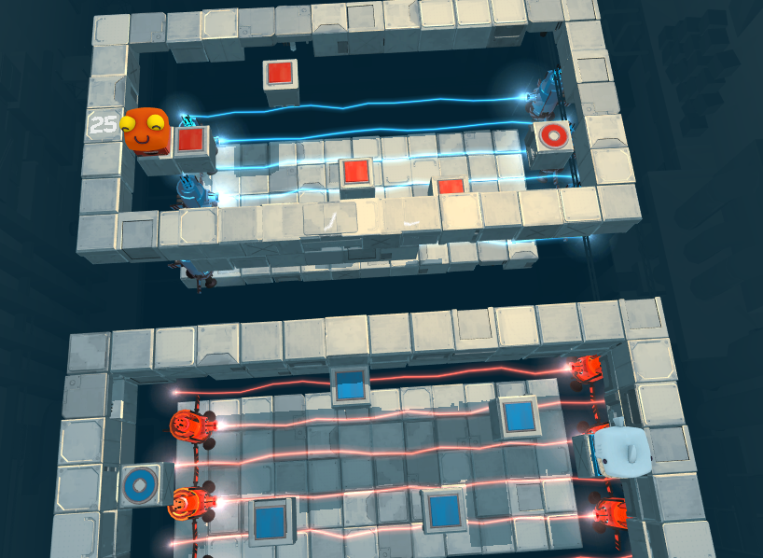
Level 25 Version 1: I wanted to take Level 24 and make it so both players are affecting each other in similar ways, so I positioned both player characters above lasers and added pressure plates to the safe points. However this is missing the crucial element of something pushing the players off of the pressure plates, which means the red player can stay on the first pressure plate for as long as needed until the blue player walks all the way to the goal, and vice versa, which is very problematic.
There are also more subtle issues such as the camera angle missing part of the level and some blocks being off-grid causing z-fighting.

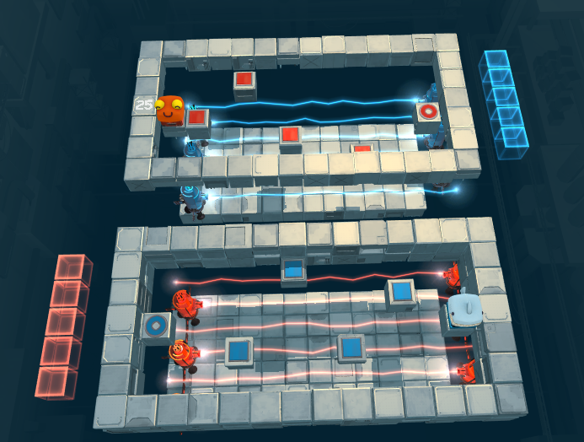
Level 25 Version 2: I fixed the issues from before, including adding a wall of moving holocubes that can push the players off their pressure plates. Since the cubes start close to the goal, this has created the interesting effect of the timing becoming harder the further the nearer the players get to winning. This exponential nature of the difficulty, combined with that fact that the cubes move back to their starting point at the same speed they move away from it, makes the speed very hard to balance.

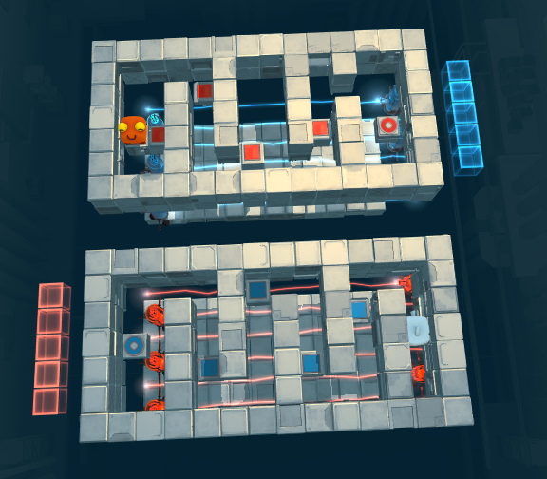
Level 25 Version 3: I added maze walls to slow the player down on their way to the end. I did this so that I could make the moving holocubes move slower without leaving enough time for a player to get all the way to the goal.
The more I test this the more I realise that since the only safe spaces are pressure plates which bring the cubes closer, this level inherently discourages waiting on the safe spaces, which is the opposite of the previous level. I think removing the pressure plates from the safe spaces will be a wise move.

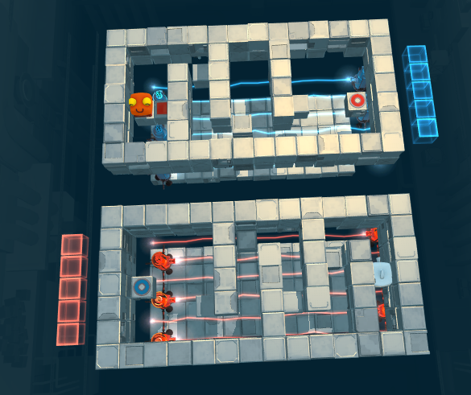
Level 25 Version 4: I removed the pressure plates from the safe spaces, but this essentially just made the whole level about racing straight to the end.

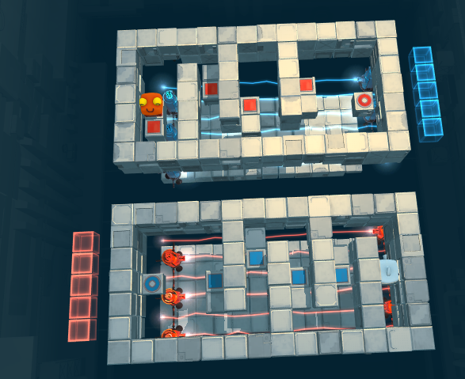
Level 25 Version 5: I’ve given each safe space a space next to it with a pressure plate on it. This way the players can stall on the safe spaces to make the holocubes reset, and they don’t get stuck because they can move onto the pressure plate next to them. I think this level will be very chaotic multiplayer, which is exciting.

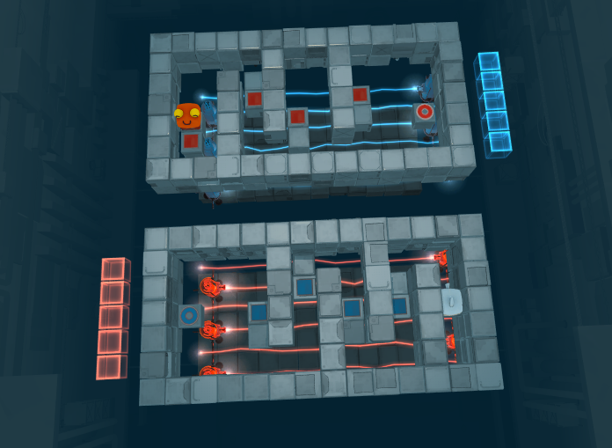
Level 25 Version 6: I updated the lighting to have a stronger contrast between the cubes below and the safe spaces.

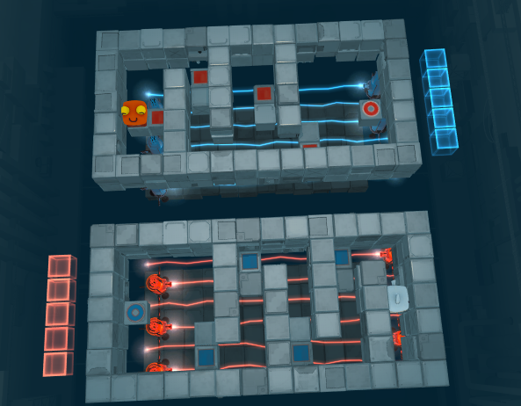
Level 25 Version 7: Being having a holocube push the player into a wall causes the physics to act up, so I changed the positioning of the pressure plates so that none have a wall behind them, preventing this from happening.

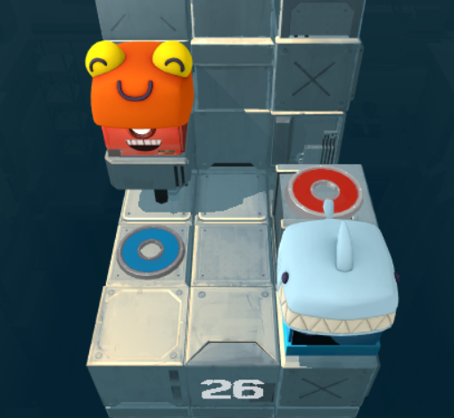
Level 26 Version 1: In playtesting players struggled to realise the could carry each other, and I realised there were some already tricky maze levels that used this mechanic when it hadn’t been introduced in any easier levels. So, I decided to make a very basic level purely for teaching the player how to carry each other. This level is just the first level of the game without the holocubes and with the red spawn point and end point lifted up a block.

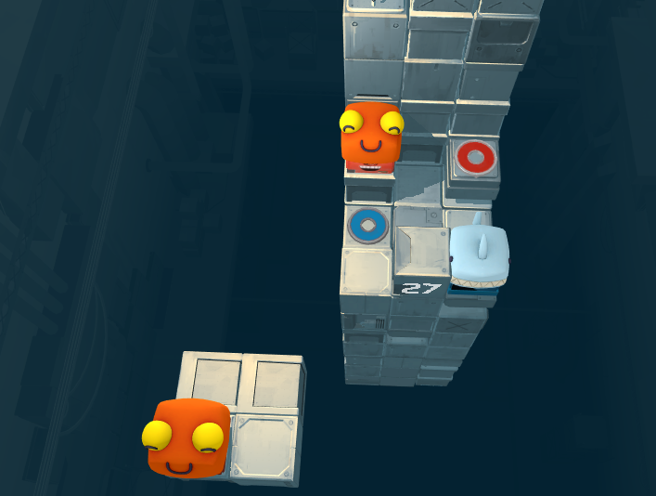
Level 27 Version 1: Level 13 requires the player to carry one player character to move it without moving its twin, which is a really interesting solution. However it is only part of that level’s solution, and it is already a tricky level without that, so I thought it might be good to make the player figure that dynamic out in a level dedicated just to that edge case. That’s what this level is, with the solution sentence of “One player has to carry another in order to stop another of the same colour from falling off the stage.”
In this level if the red player moves straight to the right its twin will fall to its death, so the player needs to be carried down to the number block so that they can move to the left, move up, and be carried to the goal to then move to the right. However, as I have just found out through testing, the level will not complete unless there is a goal for every red player.

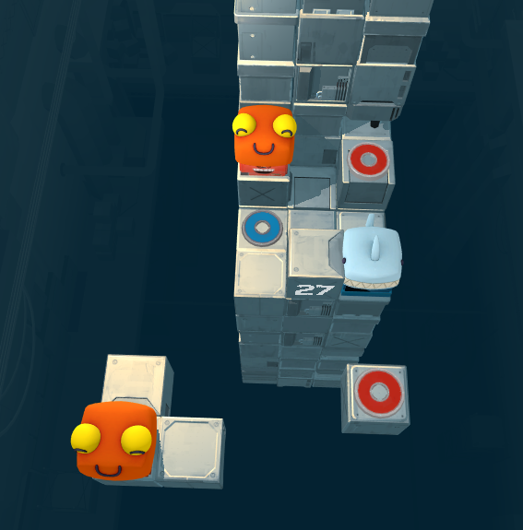
Level 27 Version 2: I needed to give the second red player a goal space, but also ensure that they couldn’t reach it accidentally within the small space the second red player has to move. To achieve this I removed the far right corner of the second red player’s platform and added a red goal space in its place. To stop the player from triggering it without carrying out the proper solution, I made it detached from the platform and only slot into place when the blue player is on its goal circle.
The removal of one of the spaces on the platform has made the puzzle more intentional by limiting the movement options for the second red player. Yet seemingly not enough, because players can still beat this level in an unexpected way: moving the red player up at the start, allowing them to move down onto the blue player, then be carried over to the left of the goal space and move right. This is still quite an interesting solution, but it doesn’t use the raised number block at all, and it is slightly different from the intended solution. As a result, what I think I will do is separate this puzzle into two versions – one that requires the number block to complete, and one that doesn’t have the number block raised at all, each with unique solutions.

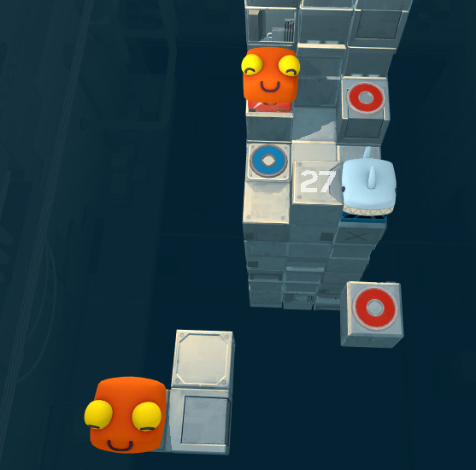
Level 27 Version 3: I changed the platform so that the player needs to move to the right on its first movement now. I thought this would force the player to use the number block, but it doesn’t at all because the player can still move up onto the red goal after moving right onto the blue player.

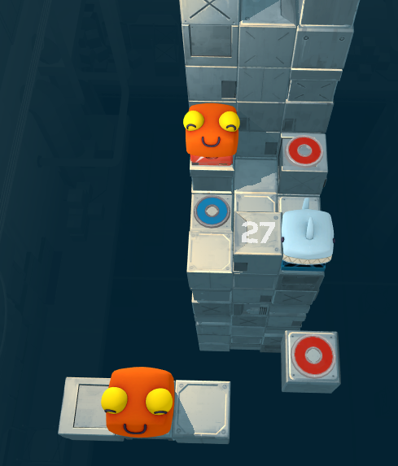
Level 27 Version 4: I’ve entirely removed the ability to move up (other than the goal square at the end) for the second red player. Instead I gave them another square of horizontal movement, so they need to manage only their movement along that axis. This forces the player to move in a more complex interesting way, finally utilising the number block.

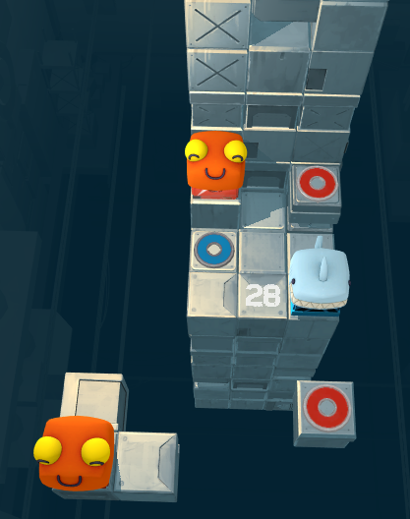
Level 28 Version 1: This is a level based on the unintended solution found in Level 27 Version 2. It is the same as that level version, except with the number block down so the player is unable to solve it in a similar way to Level 27.

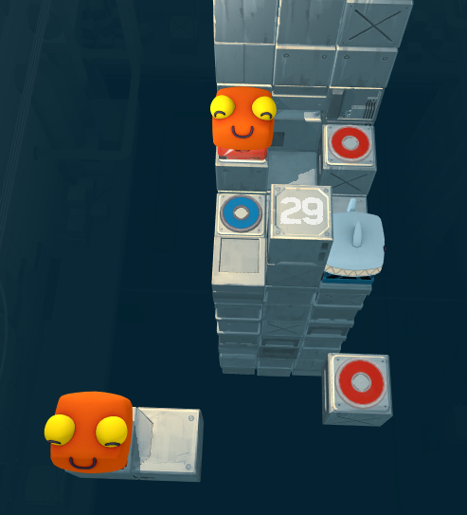
Level 29 Version 1: This was another alternate solution I came up with for Level 27, which manages to limit the second red player’s movement to only two blocks by allowing the top red player to push against the number block to the left.

Cut Levels:
Below are three levels that were based on the concept of sneaking past the other player by having the other player stand on the corner or halfway off the block they are standing on. After some playtesting, it turns out these levels were not only too difficult but also more about tricky movement than actual puzzle solving, so I figured it was best to cut them from the roster of levels for now.
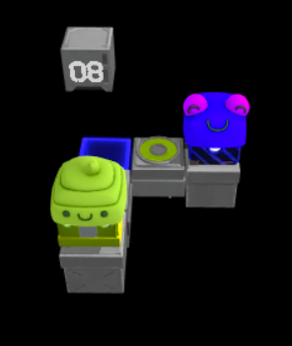
Cut Level A Version 1: This idea was based on Level 7 Version 2, and how it was completed by moving a player towards the edge of a corner piece to allow the other player cut inside the corner. Level 8 is a very simple puzzle that requires that solution.

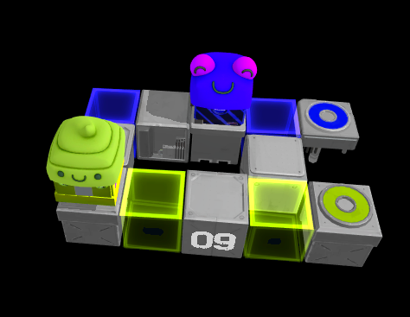
Cut Level B Version 1: Similarly to how the concept for Level 7 came from wanting to make a version of level 5 that required both players to engage with the specific movement mechanic, this is an attempt to make both players engage with the tricky movement required in Level 8. This lead to a surprisingly interesting puzzle and solution, with players appearing on either side of a gap, and having to swap sides not once but twice to solve the puzzle. While I think what I have here could already make for a fun puzzle, using the standing-on-the-edge-of-corners method from Level 8 is not the only way for the players to swap sides here. Therefore I might make some “forcing function” adjustments to make the solution conform to the original concept for this level.

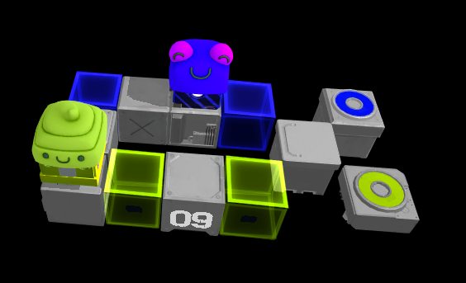
Cut Level B Version 2: By moving three blocks to the right I’ve now made it so the blue player cannot access the goal square from the start, and has to cut inside of the green player as desired. However, when they swap sides the second time this doesn’t need to be done.

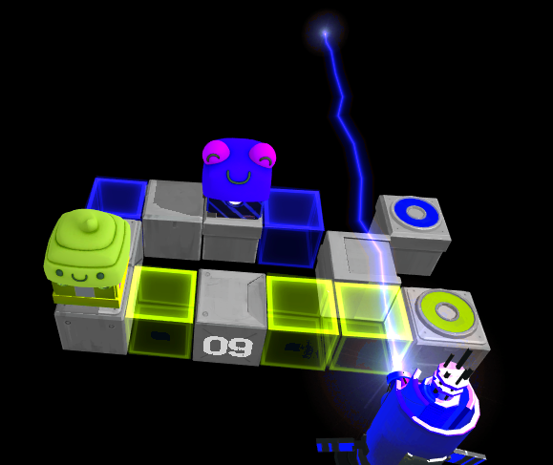
Cut Level B Version 3: I’ve added a green holocube for the blue player to stand on next to the corner the green player will cut, and a blue laser that forces the blue player to stand there. This achieves the desired solution of the level. It’s possible to complete, but quite hard – this isn’t necessarily a bad thing but means that this is possibly the furthest I can push the concept of the players manoeuvring around each other being the sole challenge of a puzzle. It is probably time to start introducing more mechanics after this, and this level may need to be moved later in the series of puzzles due to its unique difficulty.

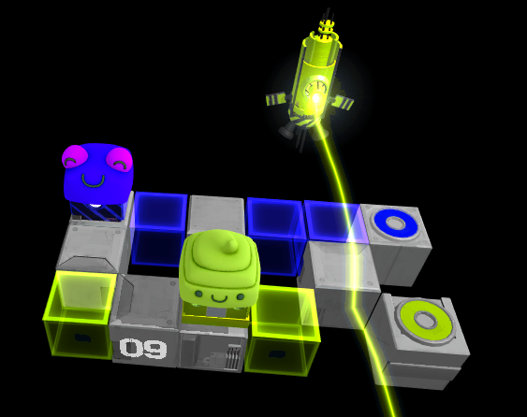
Cut Level B Version 4: Nothing really changed about the solution in this iteration, I just swapped some things around so that the laser was facing towards the camera, with the players in between. I figured since this level was already quite hard, I might as well make it a bit easier to position the player in front of the laser. This also has the added benefit of hiding the end of the from the player, which looked a bit out of place in Version 3.

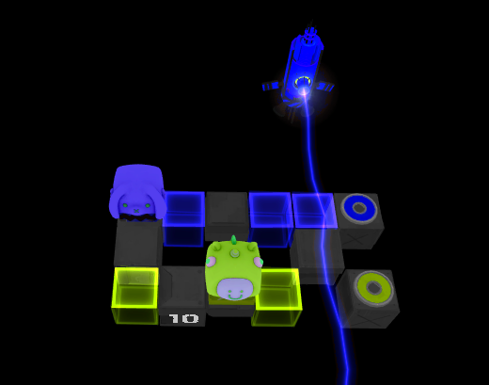
Cut Level C Version 1: I realised that simply changing the colour of the laser leads to a different solution – now the blue player must block the laser, and since they can no longer do it by standing on the blue holocube, the must do it standing on the blue goal block. I have left the blue holocube in as a misdirection, as I think noticing the difference between this level and the last will really force the player to think about how the mechanics interact. This puzzle is, however, VERY hard, so I’m unsure whether to keep it.

Making Levels For a Possible Update
After some playtesting with Pat I realised a few things. The first of these is that there is a possibility for a level pack in Death Squared’s future, and that most of the level’s I’ve provided would not be suitable to that. A large part of the reason they would not be suitable is that I was designing some of them the way I would design a single player puzzle. They have problem solving and interesting use of mechanics, but some lack cooperation. The main takeaways from how Pat would design levels for Death Squared are:
- Players need to use each other to win
- Players can kill each other
- Difficulty is in problem solving, not in executing the solution
- Every block should only have one element, for clarity’s sake
- Avoid levels that encourage taking advantage of getting stuck on walls (the splitting levels)
- Levels with multiple of the same colour player are particularly tricky to get right
- Path should be clear, but requires cooperation between players (my last two levels in the current build are a good example of this)
- If the two players aren’t communicating with each other when playing, the level needs to change so that they have to
- Avoid soft locks – killing the player is fine, but putting the player in a position where they are forced to make the decision to kill themselves in order to restart is not a great experience, especially in multiplayer
- if a level ends up feeling like it has two disparate ideas, split into two levels, hone the single ideas more (per level)
- another one I didn't explicitly delve into enough (maybe) but touched on a bit I think: if there's a difficult part of a level, front-load it in the sequence - ie
  - good: really explosively difficult challenge early in a level, players practice and solve it, later parts of level aren't as hard, finish
  - bad: players do an unchallenging early segment, then hit explosive difficulty at the end. now every retry forces them to re-tread "downtime" (proving nothing) to get back to the part they'll likely still fail some more times before getting it right

There are definitely levels of mine that incorporate a lot of these points, but I think to be release-ready all of them need to align with all these points. The biggest problem is a lack of consideration for how a level works in a multiplayer setting. To address this, when I get other people to test my levels I will only do it with two people, not with one person controlling both bots.

Luckily, a lot of the above points are very easily addressable, unluckily some of them require some levels to be completely rethought or scrapped. The splitting levels, for example, seem to invite jank and discourage collaboration in a way that is arguably inherent to the concept of those levels, so they will need to go. Level 13 is classified as a “Holocube Maze” level, but in practice it functions as a splitting level as well, so I will scrap that as well.

The diagonal levels are mostly the same as existing levels with the added twist of diagonal movement. This arguably contradicts the rule “difficulty is in problem solving, not in executing the solution”, so these should also be cut.

Level 1 and Level 2 were designed to be the first two levels for someone totally new to the game, but since I am now thinking about levels within the context of a level pack on top of the existing game, this wouldn’t be the case, and thus I don’t think these levels hold up for this purpose. Similarly, Level 26 was supposed to be a carrying tutorial, so that won’t be needed anymore either.

Players responded positively to the launching mechanic, but it doesn’t need to be reiterated more than once, so I will get rid of Level 9 and Level 11.

The carrying levels and falling floor levels also had very positive player feedback, so they can stay for now.

The holocube maze levels and spikes levels are not inherently bad in concept, but definitely need redesigning in order to fit the dot points above.

With the above thoughts in mind, I have cut about one third of the levels from the roster. Here is what it was before and what it looks like now:
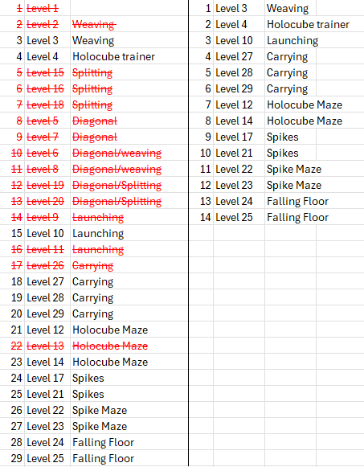

This is still plenty of levels, although this doesn’t mean they are all up to par, just that these levels are possibly salvageable. To get them to the level of quality they need to be, I will be judging each one on all of the points from Pat’s feedback, and making changes if they don’t fulfill all of those points.

Despite being reordered, I will be using the levels’ original numbers in this document for consistency, starting with Level 3.
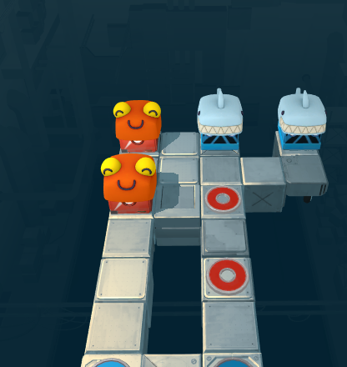
Level 3 Version 5
- Players need to use each other to win – FAIL, players just need to avoid each other to win.
- Players can kill each other – FAIL, players mostly just mess up the other player’s alignment but rarely kill them
- Difficulty is in problem solving, not in executing the solution – SUCCESS
- Every block should only have one element, for clarity’s sake – SUCCESS
- Avoid levels that encourage taking advantage of getting stuck on walls (the splitting levels) – SUCCESS
- Levels with multiple of the same colour player are particularly tricky to get right – FAIL, has multiple players of the same colour
- Path should be clear, but requires cooperation between players (my last two levels in the current build are a good example of this) – FAIL, path is not visible from start at this camera angle
- If the two players aren’t communicating with each other when playing, the level needs to change so that they have to – FAIL, playtesting has produced limited communication
- Avoid soft locks – killing the player is fine, but putting the player in a position where they are forced to make the decision to kill themselves in order to restart is not a great experience, especially in multiplayer – FAIL, players softlock each other by misaligning the pairs.
- if a level ends up feeling like it has two disparate ideas, split into two levels, hone the single ideas more (per level) – SUCCESS
- If there's a difficult part of a level, front-load it in the sequence – SUCCESS
Score: 5/11

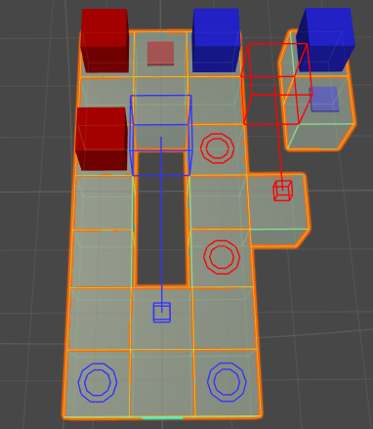
Level 3 Version 6
I moved bits from the required path away so that the players would need to step on pressure plates to move them over. This has also meant that the red players will become split up when the blue players move off their pressure plate, forcing the blue player to go on to their goal circles to bring the red players back together again. I think that is a really interesting and cool aspect to this version of the puzzle.
- Players need to use each other to win – SUCCESS
- Players can kill each other – FAIL, players mostly just mess up the other player’s alignment but rarely kill them
- Difficulty is in problem solving, not in executing the solution – SUCCESS
- Every block should only have one element, for clarity’s sake – SUCCESS
- Avoid levels that encourage taking advantage of getting stuck on walls (the splitting levels) – SUCCESS
- Levels with multiple of the same colour player are particularly tricky to get right – FAIL, has multiple players of the same colour
- Path should be clear, but requires cooperation between players (my last two levels in the current build are a good example of this) – FAIL, path is not visible from start at this camera angle
- If the two players aren’t communicating with each other when playing, the level needs to change so that they have to – UNTESTED
- Avoid soft locks – killing the player is fine, but putting the player in a position where they are forced to make the decision to kill themselves in order to restart is not a great experience, especially in multiplayer – FAIL, players softlock each other by misaligning the pairs.
- if a level ends up feeling like it has two disparate ideas, split into two levels, hone the single ideas more (per level) – SUCCESS
- If there's a difficult part of a level, front-load it in the sequence – SUCCESS
Score: 6/11

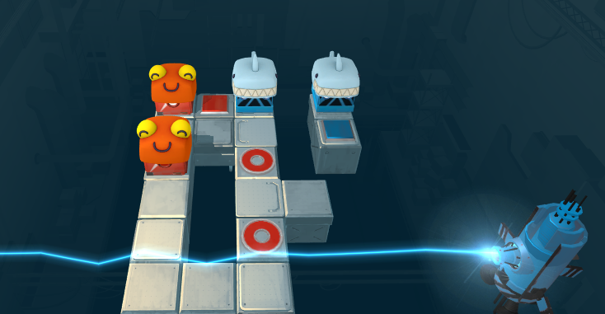
Level 3 Version 7
This is the same as Version 6 but with a blue laser that is axis mapped along the z axis to the blue player’s x axis. This allows the blue player to kill the red player.

- Players need to use each other to win – SUCCESS
- Players can kill each other – FAIL, although the blue player can now kill the red player, this is not true for vice versa
- Difficulty is in problem solving, not in executing the solution – SUCCESS
- Every block should only have one element, for clarity’s sake – SUCCESS
- Avoid levels that encourage taking advantage of getting stuck on walls (the splitting levels) – SUCCESS
- Levels with multiple of the same colour player are particularly tricky to get right – FAIL, has multiple players of the same colour
- Path should be clear, but requires cooperation between players (my last two levels in the current build are a good example of this) – FAIL, path is not visible from start at this camera angle
- If the two players aren’t communicating with each other when playing, the level needs to change so that they have to – UNTESTED
- Avoid soft locks – killing the player is fine, but putting the player in a position where they are forced to make the decision to kill themselves in order to restart is not a great experience, especially in multiplayer – FAIL, players softlock each other by misaligning the pairs.
- if a level ends up feeling like it has two disparate ideas, split into two levels, hone the single ideas more (per level) – SUCCESS
- If there's a difficult part of a level, front-load it in the sequence – SUCCESS
Score: 6/11

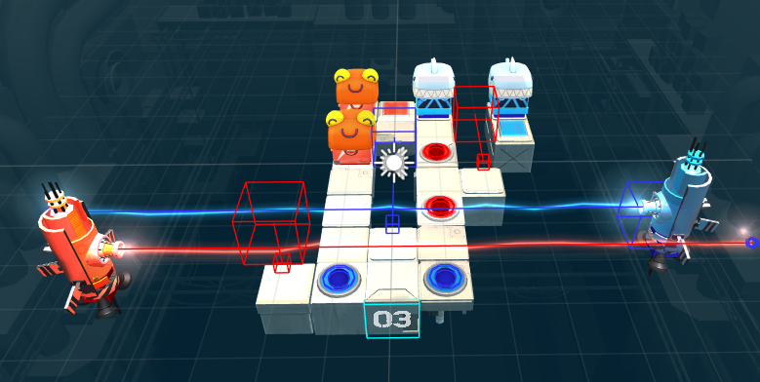
Level 3 Version 8
I added a red laser that can be blocked by standing on red pressure plates. This means that the blue player needs to move off their goals while the red player moves down to their goals.
- Players need to use each other to win – SUCCESS
- Players can kill each other – SUCCESS
- Difficulty is in problem solving, not in executing the solution – SUCCESS
- Every block should only have one element, for clarity’s sake – SUCCESS
- Avoid levels that encourage taking advantage of getting stuck on walls (the splitting levels) – SUCCESS
- Levels with multiple of the same colour player are particularly tricky to get right – FAIL, has multiple players of the same colour
- Path should be clear, but requires cooperation between players (my last two levels in the current build are a good example of this) – FAIL, path is not visible from start at this camera angle
- If the two players aren’t communicating with each other when playing, the level needs to change so that they have to – UNTESTED
- Avoid soft locks – killing the player is fine, but putting the player in a position where they are forced to make the decision to kill themselves in order to restart is not a great experience, especially in multiplayer – FAIL, players softlock each other by misaligning the pairs.
- if a level ends up feeling like it has two disparate ideas, split into two levels, hone the single ideas more (per level) – SUCCESS
- If there's a difficult part of a level, front-load it in the sequence – UNTESTED, players now need to notice that they need to avoid the red laser right near the end of the sequence, so this should be tested if players find this part harder than the rest of the level
Score: 6/11

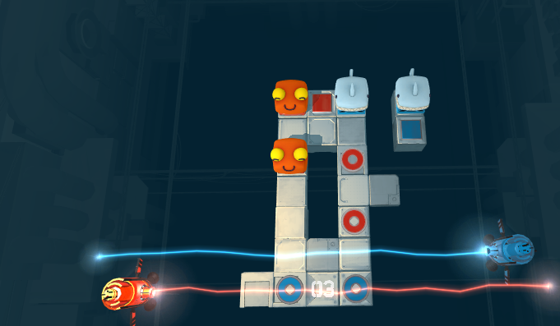
Level 3 Version 9
I changed the camera so the paths to the goals were more clear.
- Players need to use each other to win – SUCCESS
- Players can kill each other – SUCCESS
- Difficulty is in problem solving, not in executing the solution – SUCCESS
- Every block should only have one element, for clarity’s sake – SUCCESS
- Avoid levels that encourage taking advantage of getting stuck on walls (the splitting levels) – SUCCESS
- Levels with multiple of the same colour player are particularly tricky to get right – FAIL, has multiple players of the same colour
- Path should be clear, but requires cooperation between players (my last two levels in the current build are a good example of this) – SUCCESS
- If the two players aren’t communicating with each other when playing, the level needs to change so that they have to – UNTESTED
- Avoid soft locks – killing the player is fine, but putting the player in a position where they are forced to make the decision to kill themselves in order to restart is not a great experience, especially in multiplayer – FAIL, players softlock each other by misaligning the pairs.
- if a level ends up feeling like it has two disparate ideas, split into two levels, hone the single ideas more (per level) – SUCCESS
- If there's a difficult part of a level, front-load it in the sequence – UNTESTED, players now need to notice that they need to avoid the red laser right near the end of the sequence, so this should be tested if players find this part harder than the rest of the level
Score: 7/11

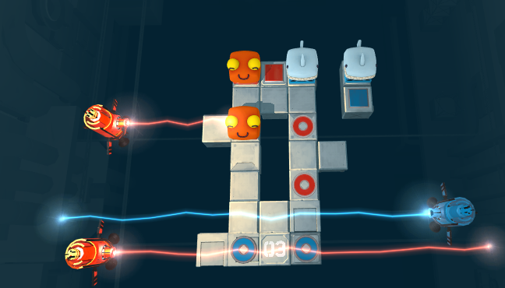
Level 3 Version 10
I added another red laser that can be blocked by a moving tile that is activated by a red pressure plate. This stops the red players from moving down off their goal to misalign the blue players in the early game, and stops the blue players from pushing the red players up off their goals and misaligning them in the late game.
- Players need to use each other to win – SUCCESS
- Players can kill each other – SUCCESS
- Difficulty is in problem solving, not in executing the solution – SUCCESS
- Every block should only have one element, for clarity’s sake – SUCCESS
- Avoid levels that encourage taking advantage of getting stuck on walls (the splitting levels) – SUCCESS
- Levels with multiple of the same colour player are particularly tricky to get right – FAIL, has multiple players of the same colour
- Path should be clear, but requires cooperation between players (my last two levels in the current build are a good example of this) – SUCCESS
- If the two players aren’t communicating with each other when playing, the level needs to change so that they have to – UNTESTED
- Avoid soft locks – killing the player is fine, but putting the player in a position where they are forced to make the decision to kill themselves in order to restart is not a great experience, especially in multiplayer – SUCCESS
- if a level ends up feeling like it has two disparate ideas, split into two levels, hone the single ideas more (per level) – SUCCESS
- If there's a difficult part of a level, front-load it in the sequence – UNTESTED, players now need to notice that they need to avoid the red laser right near the end of the sequence, so this should be tested if players find this part harder than the rest of the level
Score: 8/11

Level 4 Version 3
- Players need to use each other to win – SUCCESS
- Players can kill each other – FAIL, players mostly block each other
- Difficulty is in problem solving, not in executing the solution – FAIL, lining the floors up with the axis mapping is very specific for players
- Every block should only have one element, for clarity’s sake – SUCCESS
- Avoid levels that encourage taking advantage of getting stuck on walls (the splitting levels) – SUCCESS
- Levels with multiple of the same colour player are particularly tricky to get right – SUCCESS
- Path should be clear, but requires cooperation between players (my last two levels in the current build are a good example of this) – SUCCESS
- If the two players aren’t communicating with each other when playing, the level needs to change so that they have to – SUCCESS
- Avoid soft locks – killing the player is fine, but putting the player in a position where they are forced to make the decision to kill themselves in order to restart is not a great experience, especially in multiplayer – SUCCESS
- if a level ends up feeling like it has two disparate ideas, split into two levels, hone the single ideas more (per level) – SUCCESS
- If there's a difficult part of a level, front-load it in the sequence – SUCCESS
Score: 9/11

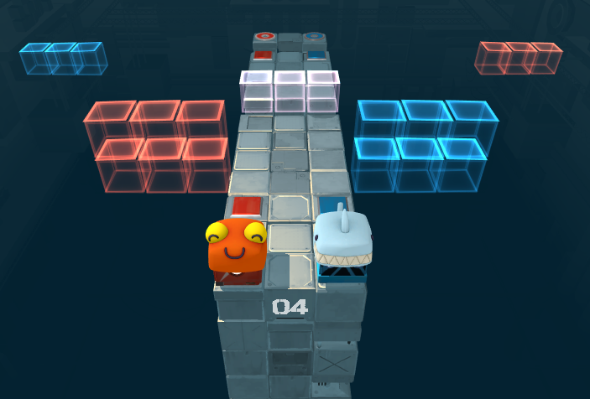
Level 4 Version 4
Changed the holocube floors to move down based on pressure plates, not axis mapping.
- Players need to use each other to win – SUCCESS
- Players can kill each other – FAIL, players mostly block each other
- Difficulty is in problem solving, not in executing the solution – SUCCESS
- Every block should only have one element, for clarity’s sake – SUCCESS
- Avoid levels that encourage taking advantage of getting stuck on walls (the splitting levels) – SUCCESS
- Levels with multiple of the same colour player are particularly tricky to get right – SUCCESS
- Path should be clear, but requires cooperation between players (my last two levels in the current build are a good example of this) – SUCCESS
- If the two players aren’t communicating with each other when playing, the level needs to change so that they have to – SUCCESS
- Avoid soft locks – killing the player is fine, but putting the player in a position where they are forced to make the decision to kill themselves in order to restart is not a great experience, especially in multiplayer – SUCCESS
- If a level ends up feeling like it has two disparate ideas, split into two levels, hone the single ideas more (per level) – SUCCESS
- If there's a difficult part of a level, front-load it in the sequence – SUCCESS
Score: 10/11

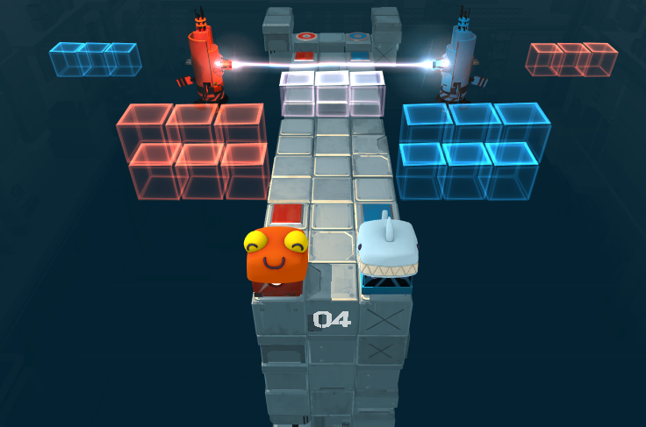
Level 4 Version 5
I added lasers above the holocube floors so that a player would be killed by them if the floor lifts up while they are on it. I also added walls near the goals so the if one player moves back while the other is on the last set of holocube floors, they will be pushed off to their death. Both of these changes give players the opportunity to kill each other, accidentally or on purpose.
- Players need to use each other to win – SUCCESS
- Players can kill each other – SUCCESS
- Difficulty is in problem solving, not in executing the solution – SUCCESS
- Every block should only have one element, for clarity’s sake – SUCCESS
- Avoid levels that encourage taking advantage of getting stuck on walls (the splitting levels) – SUCCESS
- Levels with multiple of the same colour player are particularly tricky to get right – SUCCESS
- Path should be clear, but requires cooperation between players (my last two levels in the current build are a good example of this) – SUCCESS
- If the two players aren’t communicating with each other when playing, the level needs to change so that they have to – SUCCESS
- Avoid soft locks – killing the player is fine, but putting the player in a position where they are forced to make the decision to kill themselves in order to restart is not a great experience, especially in multiplayer – SUCCESS
- If a level ends up feeling like it has two disparate ideas, split into two levels, hone the single ideas more (per level) – SUCCESS
- If there's a difficult part of a level, front-load it in the sequence – SUCCESS
Score: 11/11

Level 10 Version 1
- Players need to use each other to win – SUCCESS
- Players can kill each other – FAIL
- Difficulty is in problem solving, not in executing the solution – SUCCESS
- Every block should only have one element, for clarity’s sake – SUCCESS
- Avoid levels that encourage taking advantage of getting stuck on walls (the splitting levels) – SUCCESS
- Levels with multiple of the same colour player are particularly tricky to get right – SUCCESS
- Path should be clear, but requires cooperation between players (my last two levels in the current build are a good example of this) – SUCCESS
- If the two players aren’t communicating with each other when playing, the level needs to change so that they have to – UNTESTED
- Avoid soft locks – killing the player is fine, but putting the player in a position where they are forced to make the decision to kill themselves in order to restart is not a great experience, especially in multiplayer – FAIL, player can get launched to the left island, becoming softlocked
- If a level ends up feeling like it has two disparate ideas, split into two levels, hone the single ideas more (per level) – SUCCESS
- If there's a difficult part of a level, front-load it in the sequence – SUCCESS
Score: 8/11

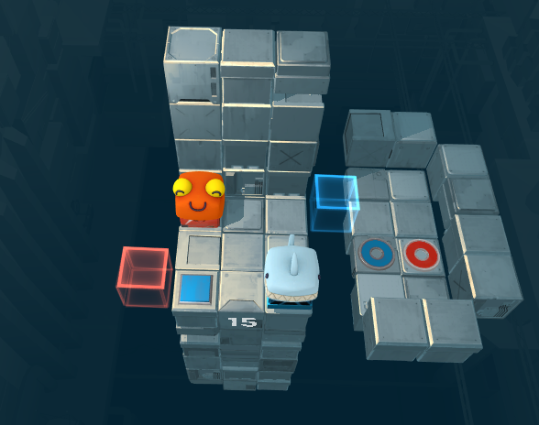
Level 10 Version 2
I removed the left island so that the red player would die if being flung to the left.
- Players need to use each other to win – SUCCESS
- Players can kill each other – FAIL, blue player can kill the red player but the red player cannot kill the blue player
- Difficulty is in problem solving, not in executing the solution – SUCCESS
- Every block should only have one element, for clarity’s sake – SUCCESS
- Avoid levels that encourage taking advantage of getting stuck on walls (the splitting levels) – SUCCESS
- Levels with multiple of the same colour player are particularly tricky to get right – SUCCESS
- Path should be clear, but requires cooperation between players (my last two levels in the current build are a good example of this) – SUCCESS
- If the two players aren’t communicating with each other when playing, the level needs to change so that they have to – UNTESTED
- Avoid soft locks – killing the player is fine, but putting the player in a position where they are forced to make the decision to kill themselves in order to restart is not a great experience, especially in multiplayer – SUCCESS
- If a level ends up feeling like it has two disparate ideas, split into two levels, hone the single ideas more (per level) – SUCCESS
- If there's a difficult part of a level, front-load it in the sequence – SUCCESS
Score: 9/11

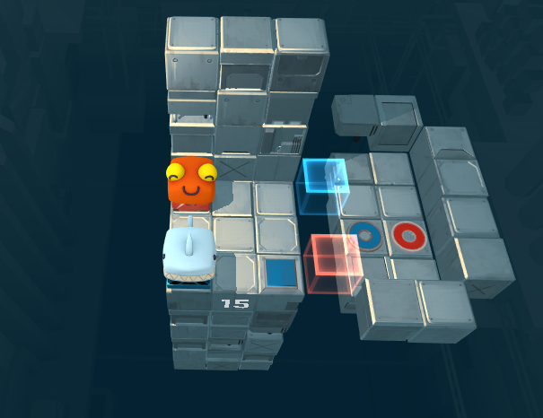
Level 10 Version 3
I made the red holocube move right to left so that it could kill the blue player.
- Players need to use each other to win – SUCCESS
- Players can kill each other – SUCCESS
- Difficulty is in problem solving, not in executing the solution – SUCCESS
- Every block should only have one element, for clarity’s sake – SUCCESS
- Avoid levels that encourage taking advantage of getting stuck on walls (the splitting levels) – SUCCESS
- Levels with multiple of the same colour player are particularly tricky to get right – SUCCESS
- Path should be clear, but requires cooperation between players (my last two levels in the current build are a good example of this) – SUCCESS
- If the two players aren’t communicating with each other when playing, the level needs to change so that they have to – UNTESTED
- Avoid soft locks – killing the player is fine, but putting the player in a position where they are forced to make the decision to kill themselves in order to restart is not a great experience, especially in multiplayer – SUCCESS
- If a level ends up feeling like it has two disparate ideas, split into two levels, hone the single ideas more (per level) – SUCCESS
- If there's a difficult part of a level, front-load it in the sequence – SUCCESS
Score: 10/11

Level 27 Version 4
- Players need to use each other to win – FAIL, the blue player can reach its goal without help from the red player
- Players can kill each other – FAIL
- Difficulty is in problem solving, not in executing the solution – SUCCESS
- Every block should only have one element, for clarity’s sake – SUCCESS
- Avoid levels that encourage taking advantage of getting stuck on walls (the splitting levels) – FAIL, doesn’t encourage pushing against walls but does encourage janking by standing part way on a square to get an unintended solution
- Levels with multiple of the same colour player are particularly tricky to get right – FAIL, this level has two red players
- Path should be clear, but requires cooperation between players (my last two levels in the current build are a good example of this) – SUCCESS
- If the two players aren’t communicating with each other when playing, the level needs to change so that they have to – UNTESTED
- Avoid soft locks – killing the player is fine, but putting the player in a position where they are forced to make the decision to kill themselves in order to restart is not a great experience, especially in multiplayer – FAIL, if the red player falls onto the floor it soft locks the puzzle
- If a level ends up feeling like it has two disparate ideas, split into two levels, hone the single ideas more (per level) – SUCCESS
- If there's a difficult part of a level, front-load it in the sequence – SUCCESS
Score: 5/11

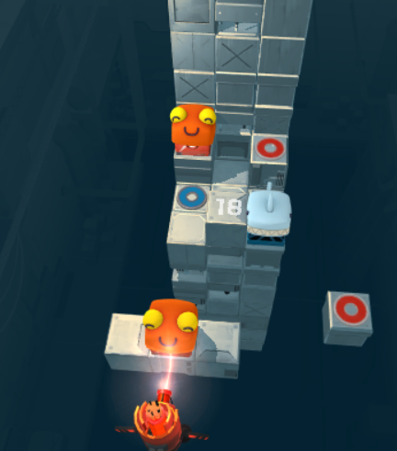
Level 27 Version 5
I added a laser for the red player to block to let the blue onto its goal. However, this makes the level impossible.

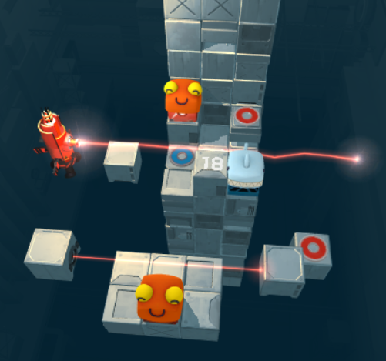
Level 27 Version 6
I added a trip wire that blocks the laser while the red player is triggering it.
- Players need to use each other to win – SUCCESS
- Players can kill each other – FAIL, red player can kill the blue player but not vice versa
- Difficulty is in problem solving, not in executing the solution – SUCCESS
- Every block should only have one element, for clarity’s sake – SUCCESS
- Avoid levels that encourage taking advantage of getting stuck on walls (the splitting levels) – FAIL, doesn’t encourage pushing against walls but does encourage janking by standing part way on a square to get an unintended solution
- Levels with multiple of the same colour player are particularly tricky to get right – FAIL, this level has two red players
- Path should be clear, but requires cooperation between players (my last two levels in the current build are a good example of this) – SUCCESS
- If the two players aren’t communicating with each other when playing, the level needs to change so that they have to – UNTESTED
- Avoid soft locks – killing the player is fine, but putting the player in a position where they are forced to make the decision to kill themselves in order to restart is not a great experience, especially in multiplayer – FAIL, if the red player falls onto the floor it soft locks the puzzle
- If a level ends up feeling like it has two disparate ideas, split into two levels, hone the single ideas more (per level) – SUCCESS
- If there's a difficult part of a level, front-load it in the sequence – SUCCESS
Score: 6/11

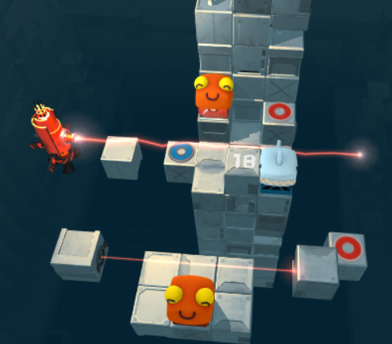

Level 27 Version 7
I moved the blue goal one space to the left, to avoid the players cheating by moving the red player up onto it off the number block onto the blue player while the blue goal is activated.
- Players need to use each other to win – SUCCESS
- Players can kill each other – FAIL, red player can kill the blue player but not vice versa
- Difficulty is in problem solving, not in executing the solution – SUCCESS
- Every block should only have one element, for clarity’s sake – SUCCESS
- Avoid levels that encourage taking advantage of getting stuck on walls (the splitting levels) – SUCCESS
- Levels with multiple of the same colour player are particularly tricky to get right – FAIL, this level has two red players
- Path should be clear, but requires cooperation between players (my last two levels in the current build are a good example of this) – SUCCESS
- If the two players aren’t communicating with each other when playing, the level needs to change so that they have to – UNTESTED
- Avoid soft locks – killing the player is fine, but putting the player in a position where they are forced to make the decision to kill themselves in order to restart is not a great experience, especially in multiplayer – FAIL, if the red player falls onto the floor it soft locks the puzzle
- If a level ends up feeling like it has two disparate ideas, split into two levels, hone the single ideas more (per level) – SUCCESS
- If there's a difficult part of a level, front-load it in the sequence – SUCCESS
Score: 7/11

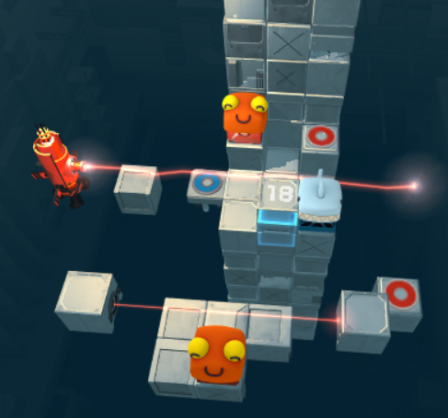
Level 27 Version 8
- Players need to use each other to win – SUCCESS
- Players can kill each other – SUCCESS
- Difficulty is in problem solving, not in executing the solution – SUCCESS
- Every block should only have one element, for clarity’s sake – SUCCESS
- Avoid levels that encourage taking advantage of getting stuck on walls (the splitting levels) – FAIL, red players can now get stuck on the blue holocube
- Levels with multiple of the same colour player are particularly tricky to get right – FAIL, this level has two red players
- Path should be clear, but requires cooperation between players (my last two levels in the current build are a good example of this) – SUCCESS
- If the two players aren’t communicating with each other when playing, the level needs to change so that they have to – UNTESTED
- Avoid soft locks – killing the player is fine, but putting the player in a position where they are forced to make the decision to kill themselves in order to restart is not a great experience, especially in multiplayer – FAIL, if the red player falls onto the floor it soft locks the puzzle
- If a level ends up feeling like it has two disparate ideas, split into two levels, hone the single ideas more (per level) – SUCCESS
- If there's a difficult part of a level, front-load it in the sequence – SUCCESS
Score: 7/11

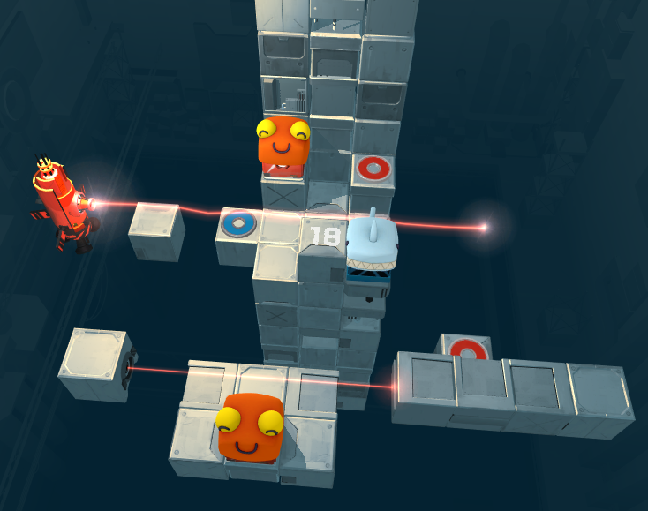
Level 27 Version 9
I added four blocks to the right which a big blue spike will come out of to the left as the blue player moves left. This fulfilled the ability to kill the red player without needing the blue holocube, so I got rid of the blue holocube, which solved some collision issues.
- Players need to use each other to win – SUCCESS
- Players can kill each other – SUCCESS
- Difficulty is in problem solving, not in executing the solution – SUCCESS
- Every block should only have one element, for clarity’s sake – SUCCESS
- Avoid levels that encourage taking advantage of getting stuck on walls (the splitting levels) – SUCCESS
- Levels with multiple of the same colour player are particularly tricky to get right – FAIL, this level has two red players
- Path should be clear, but requires cooperation between players (my last two levels in the current build are a good example of this) – SUCCESS
- If the two players aren’t communicating with each other when playing, the level needs to change so that they have to – UNTESTED
- Avoid soft locks – killing the player is fine, but putting the player in a position where they are forced to make the decision to kill themselves in order to restart is not a great experience, especially in multiplayer – FAIL, if the red player falls onto the floor it soft locks the puzzle
- If a level ends up feeling like it has two disparate ideas, split into two levels, hone the single ideas more (per level) – SUCCESS
- If there's a difficult part of a level, front-load it in the sequence – SUCCESS
Score: 8/11

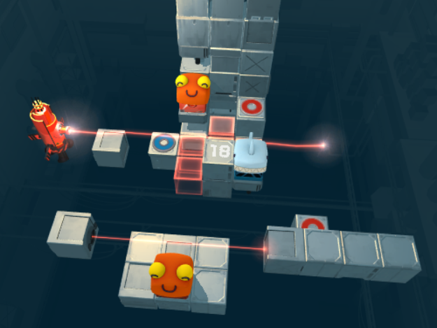
Level 27 Version 10
I replaced much of the floor with red holocubes so that the red player would die instead of soft lock when falling off.
- Players need to use each other to win – SUCCESS
- Players can kill each other – SUCCESS
- Difficulty is in problem solving, not in executing the solution – SUCCESS
- Every block should only have one element, for clarity’s sake – SUCCESS
- Avoid levels that encourage taking advantage of getting stuck on walls (the splitting levels) – FAIL, this level encourages and even requires jank to win as the player needs to get on the blue goal without moving the spike too far to the left in order to win. The player can also cheat by only just getting the red player barely on both its squares (fix this by making the red player die if its on the bottom goal square when the goal square moves back to the right)
- Levels with multiple of the same colour player are particularly tricky to get right – FAIL, this level has two red players
- Path should be clear, but requires cooperation between players (my last two levels in the current build are a good example of this) – SUCCESS
- If the two players aren’t communicating with each other when playing, the level needs to change so that they have to – SUCCESS
- Avoid soft locks – killing the player is fine, but putting the player in a position where they are forced to make the decision to kill themselves in order to restart is not a great experience, especially in multiplayer – SUCCESS
- If a level ends up feeling like it has two disparate ideas, split into two levels, hone the single ideas more (per level) – SUCCESS
- If there's a difficult part of a level, front-load it in the sequence – SUCCESS
Score: 9/11

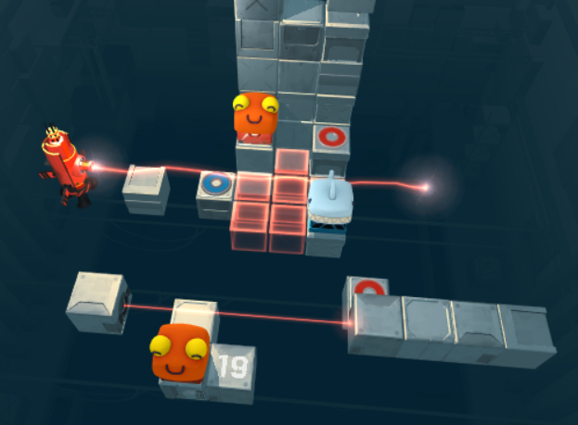
Level 28 Version 2
Implemented the holocube floor, laser, and spike changes from the previous level. However, this makes the level impossible because it forces the red player to move up on their first turn.

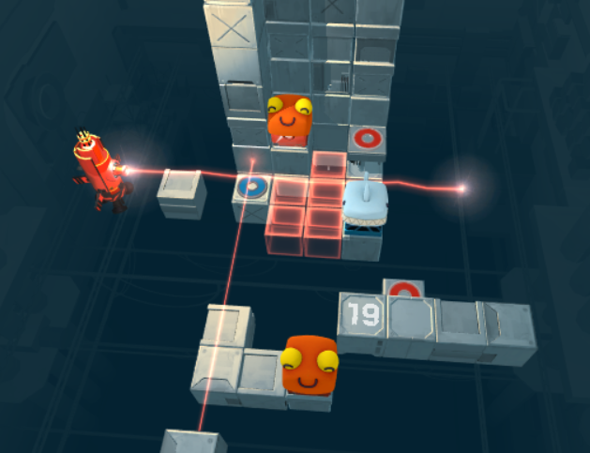
Level 28 Version 3
Changed the alignment of the bottom red player’s platform and the red trip wire, and added a wall to the left of the top red player so that the red players could move left. Also turned the spike off.
- Players need to use each other to win – SUCCESS
- Players can kill each other – FAIL, blue player cannot kill the red player
- Difficulty is in problem solving, not in executing the solution – SUCCESS
- Every block should only have one element, for clarity’s sake – SUCCESS
- Avoid levels that encourage taking advantage of getting stuck on walls (the splitting levels) – SUCCESS
- Levels with multiple of the same colour player are particularly tricky to get right – FAIL, this level has two red players
- Path should be clear, but requires cooperation between players (my last two levels in the current build are a good example of this) – SUCCESS
- If the two players aren’t communicating with each other when playing, the level needs to change so that they have to – UNTESTED
- Avoid soft locks – killing the player is fine, but putting the player in a position where they are forced to make the decision to kill themselves in order to restart is not a great experience, especially in multiplayer – SUCCESS
- If a level ends up feeling like it has two disparate ideas, split into two levels, hone the single ideas more (per level) – SUCCESS
- If there's a difficult part of a level, front-load it in the sequence – SUCCESS
Score: 8/11

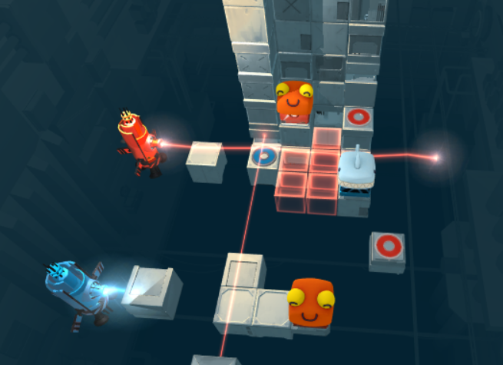
Level 28 Version 4
I added a blue laser that stops being blocked when the blue player reaches their goal, giving the blue player the opportunity to kill the red player.
- Players need to use each other to win – SUCCESS
- Players can kill each other – SUCCESS
- Difficulty is in problem solving, not in executing the solution – SUCCESS
- Every block should only have one element, for clarity’s sake – SUCCESS
- Avoid levels that encourage taking advantage of getting stuck on walls (the splitting levels) – SUCCESS
- Levels with multiple of the same colour player are particularly tricky to get right – FAIL, this level has two red players
- Path should be clear, but requires cooperation between players (my last two levels in the current build are a good example of this) – SUCCESS
- If the two players aren’t communicating with each other when playing, the level needs to change so that they have to – UNTESTED
- Avoid soft locks – killing the player is fine, but putting the player in a position where they are forced to make the decision to kill themselves in order to restart is not a great experience, especially in multiplayer – SUCCESS
- If a level ends up feeling like it has two disparate ideas, split into two levels, hone the single ideas more (per level) – SUCCESS
- If there's a difficult part of a level, front-load it in the sequence – SUCCESS
Score: 9/11

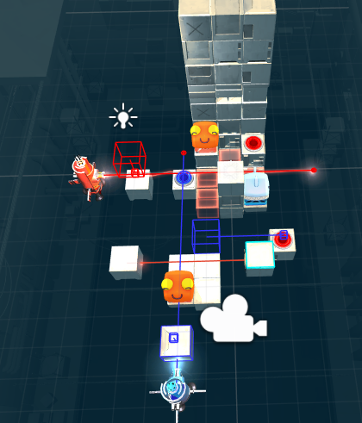
Level 29 Version 2
Based on the previous two levels, I set up a similar system of lasers and moving blocks to allow the players to kill each other. However, the blue laser falls outside of the camera which may be confusing for players.

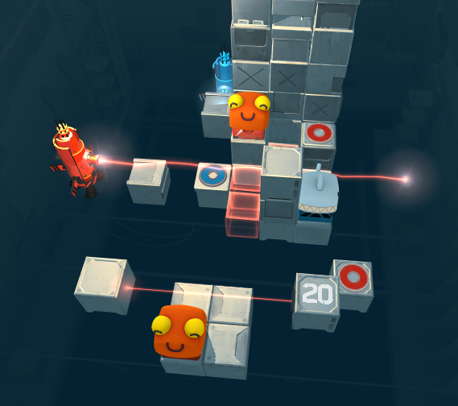
Level 29 Version 3
I swapped the blue laser and the cube blocking it to the other side to put it in better view of the camera.
- Players need to use each other to win – SUCCESS
- Players can kill each other – SUCCESS
- Difficulty is in problem solving, not in executing the solution – SUCCESS
- Every block should only have one element, for clarity’s sake – SUCCESS
- Avoid levels that encourage taking advantage of getting stuck on walls (the splitting levels) – SUCCESS
- Levels with multiple of the same colour player are particularly tricky to get right – FAIL, this level has two red players
- Path should be clear, but requires cooperation between players (my last two levels in the current build are a good example of this) – SUCCESS
- If the two players aren’t communicating with each other when playing, the level needs to change so that they have to – UNTESTED
- Avoid soft locks – killing the player is fine, but putting the player in a position where they are forced to make the decision to kill themselves in order to restart is not a great experience, especially in multiplayer – SUCCESS
- If a level ends up feeling like it has two disparate ideas, split into two levels, hone the single ideas more (per level) – SUCCESS
- If there's a difficult part of a level, front-load it in the sequence – SUCCESS
Score: 9/11

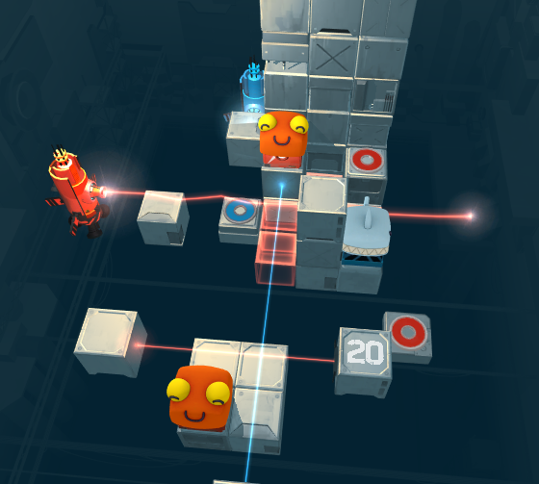
Level 29 Version 4
I added a blue tripwire so that the blue player could kill the red player more easily. However, I realised that the red player can also trigger this tripwire, making this level impossible.

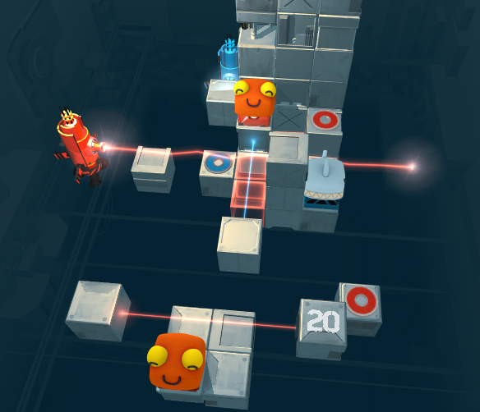
Level 29 Version 5
Moved the tripwire so that the bottom red player couldn’t trigger it.
- Players need to use each other to win – SUCCESS
- Players can kill each other – SUCCESS
- Difficulty is in problem solving, not in executing the solution – SUCCESS
- Every block should only have one element, for clarity’s sake – SUCCESS
- Avoid levels that encourage taking advantage of getting stuck on walls (the splitting levels) – SUCCESS
- Levels with multiple of the same colour player are particularly tricky to get right – FAIL, this level has two red players
- Path should be clear, but requires cooperation between players (my last two levels in the current build are a good example of this) – SUCCESS
- If the two players aren’t communicating with each other when playing, the level needs to change so that they have to – UNTESTED
- Avoid soft locks – killing the player is fine, but putting the player in a position where they are forced to make the decision to kill themselves in order to restart is not a great experience, especially in multiplayer – SUCCESS
- If a level ends up feeling like it has two disparate ideas, split into two levels, hone the single ideas more (per level) – SUCCESS
- If there's a difficult part of a level, front-load it in the sequence – SUCCESS
Score: 9/11

Level 12 Version 4
- Players need to use each other to win – FAIL, the blue player does not need the red player in order to win
- Players can kill each other – FAIL, neither player can kill each other
- Difficulty is in problem solving, not in executing the solution – FAIL, players often fall off paths or get stuck on walls
- Every block should only have one element, for clarity’s sake – SUCCESS
- Avoid levels that encourage taking advantage of getting stuck on walls (the splitting levels) – SUCCESS
- Levels with multiple of the same colour player are particularly tricky to get right – SUCCESS
- Path should be clear, but requires cooperation between players (my last two levels in the current build are a good example of this) – FAIL, most of the paths the players take, they take individually
- If the two players aren’t communicating with each other when playing, the level needs to change so that they have to – FAIL, at least for the first half of the maze
- Avoid soft locks – killing the player is fine, but putting the player in a position where they are forced to make the decision to kill themselves in order to restart is not a great experience, especially in multiplayer – FAIL, the blue player reaching their goal before the red player does is a soft lock
- If a level ends up feeling like it has two disparate ideas, split into two levels, hone the single ideas more (per level) – FAIL, the first maze part has little impact on the carrying part of the puzzle
- If there's a difficult part of a level, front-load it in the sequence – FAIL, the first half of the puzzle is easy and tedious compared to the latter half
Score: 3/11

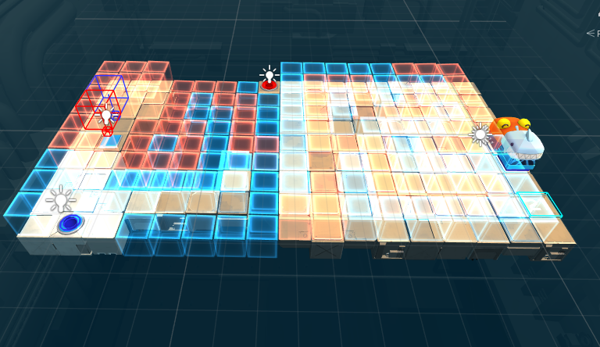
Level 12 Version 5
I removed the pressure plate from the lifting block so that the blue player can’t lift themselves up. I then made one of the blocks lift from the red goal triggering, therefore making the blue player rely on the red player.
- Players need to use each other to win – SUCCESS
- Players can kill each other – FAIL, neither player can kill each other
- Difficulty is in problem solving, not in executing the solution – FAIL, players often fall off paths or get stuck on walls
- Every block should only have one element, for clarity’s sake – SUCCESS
- Avoid levels that encourage taking advantage of getting stuck on walls (the splitting levels) – SUCCESS
- Levels with multiple of the same colour player are particularly tricky to get right – SUCCESS
- Path should be clear, but requires cooperation between players (my last two levels in the current build are a good example of this) – FAIL, most of the paths the players take, they take individually
- If the two players aren’t communicating with each other when playing, the level needs to change so that they have to – FAIL, at least for the first half of the maze
- Avoid soft locks – killing the player is fine, but putting the player in a position where they are forced to make the decision to kill themselves in order to restart is not a great experience, especially in multiplayer – SUCCESS
- If a level ends up feeling like it has two disparate ideas, split into two levels, hone the single ideas more (per level) – FAIL, the first maze part has little impact on the carrying part of the puzzle
- If there's a difficult part of a level, front-load it in the sequence – FAIL, the first half of the puzzle is easy and tedious compared to the latter half
Score: 5/11

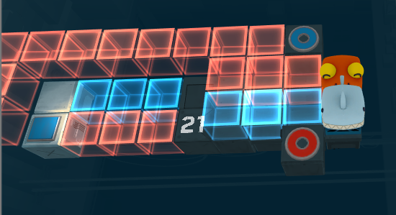
Level 12 Version 6
A lot of the issues with this level seemed to stem from the long finicky maze at the start adding noise to the puzzle. So I remade the level to be small and straight forward, keeping the same solution but without trying to misdirect players with a maze.
- Players need to use each other to win – SUCCESS
- Players can kill each other – FAIL, neither player can kill each other
- Difficulty is in problem solving, not in executing the solution – FAIL, players often fall off paths or get stuck on walls
- Every block should only have one element, for clarity’s sake – SUCCESS
- Avoid levels that encourage taking advantage of getting stuck on walls (the splitting levels) – SUCCESS
- Levels with multiple of the same colour player are particularly tricky to get right – SUCCESS
- Path should be clear, but requires cooperation between players (my last two levels in the current build are a good example of this) – FAIL, most of the paths the players take, they take individually
- If the two players aren’t communicating with each other when playing, the level needs to change so that they have to – FAIL, at least for the first half of the maze
- Avoid soft locks – killing the player is fine, but putting the player in a position where they are forced to make the decision to kill themselves in order to restart is not a great experience, especially in multiplayer – SUCCESS
- If a level ends up feeling like it has two disparate ideas, split into two levels, hone the single ideas more (per level) – SUCCESS
- If there's a difficult part of a level, front-load it in the sequence – FAIL, the first half of the puzzle is easy and tedious compared to the latter half
Score: 6/11

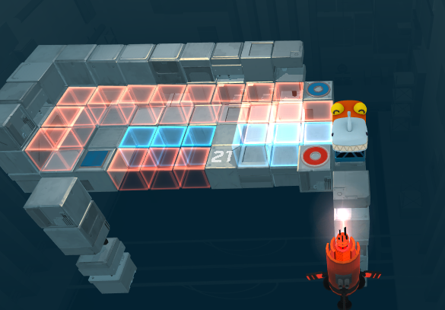
Level 12 Version 7
This version has more walls and floors to make executing the solution easier. It also has a red laser that follows the red player’s horizontal movement and vertical movement so that the red player can kill the blue player. I also generally improved the lighting and camera angle.
- Players need to use each other to win – SUCCESS
- Players can kill each other – FAIL, the blue player cannot kill the red player
- Difficulty is in problem solving, not in executing the solution – SUCCESS
- Every block should only have one element, for clarity’s sake – SUCCESS
- Avoid levels that encourage taking advantage of getting stuck on walls (the splitting levels) – SUCCESS
- Levels with multiple of the same colour player are particularly tricky to get right – SUCCESS
- Path should be clear, but requires cooperation between players (my last two levels in the current build are a good example of this) – FAIL, most of the paths the players take, they take individually
- If the two players aren’t communicating with each other when playing, the level needs to change so that they have to – FAIL, at least for the first half of the maze
- Avoid soft locks – killing the player is fine, but putting the player in a position where they are forced to make the decision to kill themselves in order to restart is not a great experience, especially in multiplayer – SUCCESS
- If a level ends up feeling like it has two disparate ideas, split into two levels, hone the single ideas more (per level) – SUCCESS
- If there's a difficult part of a level, front-load it in the sequence – FAIL, the first half of the puzzle is easy and tedious compared to the latter half
Score: 7/11

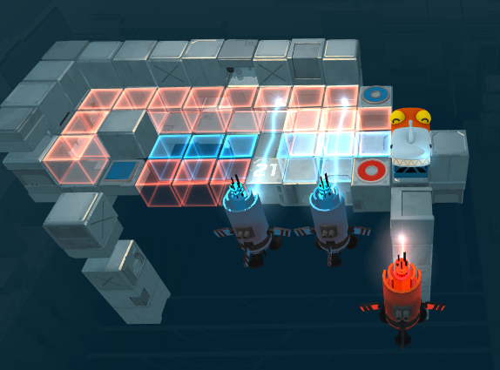
Level 12 Version 8
I tied adding blue lasers that the blue player could deactivate by stepping out from the blue trip wire along the bottom row, but having this tripwire there soft locked the level.

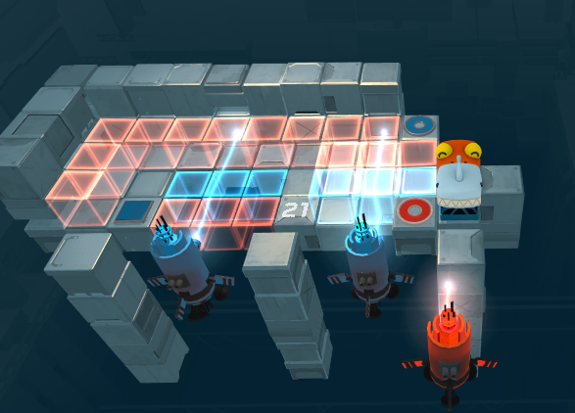
Level 12 Version 9
I then tried to make the players use the laser beamers to block the other lasers, but their hitboxes are not big enough to do this smoothly.

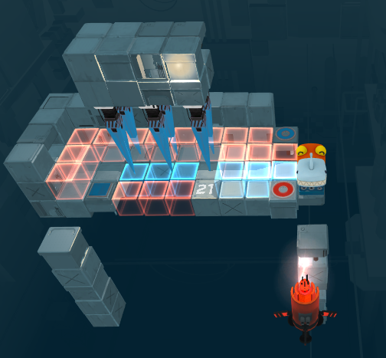
Level 12 Version 10
I decided the way I would let the blue player kill the red player would be to have descending spikes depending on the blue player’s x axis. I also changed the camera angle to make depth clearer.
- Players need to use each other to win – SUCCESS
- Players can kill each other – SUCCESS
- Difficulty is in problem solving, not in executing the solution – SUCCESS
- Every block should only have one element, for clarity’s sake – SUCCESS
- Avoid levels that encourage taking advantage of getting stuck on walls (the splitting levels) – SUCCESS
- Levels with multiple of the same colour player are particularly tricky to get right – SUCCESS
- Path should be clear, but requires cooperation between players (my last two levels in the current build are a good example of this) – SUCCESS
- If the two players aren’t communicating with each other when playing, the level needs to change so that they have to – UNTESTED
- Avoid soft locks – killing the player is fine, but putting the player in a position where they are forced to make the decision to kill themselves in order to restart is not a great experience, especially in multiplayer – SUCCESS
- If a level ends up feeling like it has two disparate ideas, split into two levels, hone the single ideas more (per level) – SUCCESS
- If there's a difficult part of a level, front-load it in the sequence – SUCCESS
Score: 10/11

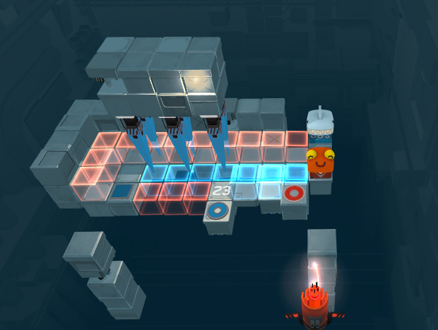
Level 14 Version 5:
I took what I did to Level 12 and applied it level 14, while maintaining the same solution sentence “One player moves along the top of a holocube maze, the other along the bottom, and they need to swap when they get to the end and then go back through the maze on the other layer”.
- Players need to use each other to win – FAIL, the blue player doesn’t use the red player to reach its goal
- Players can kill each other – FAIL, its very rare either player get a chance to kill the other
- Difficulty is in problem solving, not in executing the solution – SUCCESS
- Every block should only have one element, for clarity’s sake – SUCCESS
- Avoid levels that encourage taking advantage of getting stuck on walls (the splitting levels) – SUCCESS
- Levels with multiple of the same colour player are particularly tricky to get right – SUCCESS
- Path should be clear, but requires cooperation between players (my last two levels in the current build are a good example of this) – FAIL, doesn’t require much cooperation
- If the two players aren’t communicating with each other when playing, the level needs to change so that they have to – UNTESTED
- Avoid soft locks – killing the player is fine, but putting the player in a position where they are forced to make the decision to kill themselves in order to restart is not a great experience, especially in multiplayer – FAIL, the blue player can move onto the red player’s spawn point and soft lock
- If a level ends up feeling like it has two disparate ideas, split into two levels, hone the single ideas more (per level) – SUCCESS
- If there's a difficult part of a level, front-load it in the sequence – SUCCESS
Score: 6/11

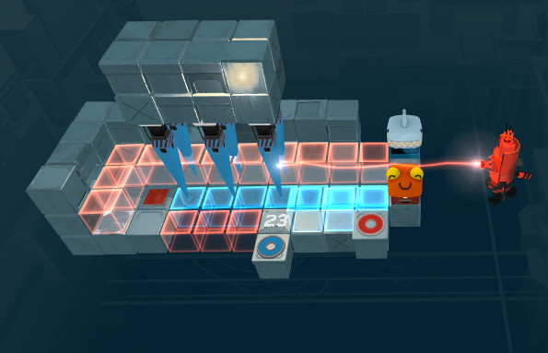
Level 14 Version 6
The red laser following the red player didn’t really work for this level, because the players are on different heights. Instead, I put a red laser at the blue player’s height, so the red player needs to move on to the new red pressure plate to move that space up and block the laser. This also prevents the soft lock mentioned earlier.
- Players need to use each other to win – SUCCESS
- Players can kill each other – FAIL, its very rare the blue player gets the chance to kill the red player
- Difficulty is in problem solving, not in executing the solution – FAIL, because the blue player now no longer has the option to move on to where the red pressure plate is, they need to go all the way around and close to the edge.
- Every block should only have one element, for clarity’s sake – SUCCESS
- Avoid levels that encourage taking advantage of getting stuck on walls (the splitting levels) – FAIL, player can take advantage of subtle movement by moving the blue player just specific enough so the spikes can block the laser
- Levels with multiple of the same colour player are particularly tricky to get right – SUCCESS
- Path should be clear, but requires cooperation between players (my last two levels in the current build are a good example of this) – SUCCESS
- If the two players aren’t communicating with each other when playing, the level needs to change so that they have to – UNTESTED
- Avoid soft locks – killing the player is fine, but putting the player in a position where they are forced to make the decision to kill themselves in order to restart is not a great experience, especially in multiplayer – SUCCESS
- If a level ends up feeling like it has two disparate ideas, split into two levels, hone the single ideas more (per level) – SUCCESS
- If there's a difficult part of a level, front-load it in the sequence – SUCCESS
Score: 7/11

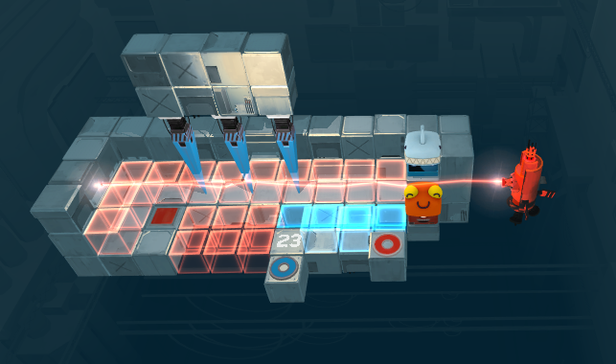
Level 14 Version 7
I removed the row of spikes that could block the laser. To make sure the red player couldn’t go through the space left by removing those spikes, I replaced the blue holocubes on that part of the path. This doesn’t mean the blue player can shortcut to them though, because the laser still prevents that, which is good.
- Players need to use each other to win – SUCCESS
- Players can kill each other – FAIL, its very rare the blue player gets the chance to kill the red player
- Difficulty is in problem solving, not in executing the solution – FAIL, because the blue player now no longer has the option to move on to where the red pressure plate is, they need to go all the way around and close to the edge.
- Every block should only have one element, for clarity’s sake – SUCCESS
- Avoid levels that encourage taking advantage of getting stuck on walls (the splitting levels) – SUCCESS
- Levels with multiple of the same colour player are particularly tricky to get right – SUCCESS
- Path should be clear, but requires cooperation between players (my last two levels in the current build are a good example of this) – SUCCESS
- If the two players aren’t communicating with each other when playing, the level needs to change so that they have to – UNTESTED
- Avoid soft locks – killing the player is fine, but putting the player in a position where they are forced to make the decision to kill themselves in order to restart is not a great experience, especially in multiplayer – SUCCESS
- If a level ends up feeling like it has two disparate ideas, split into two levels, hone the single ideas more (per level) – SUCCESS
- If there's a difficult part of a level, front-load it in the sequence – SUCCESS
Score: 8/11

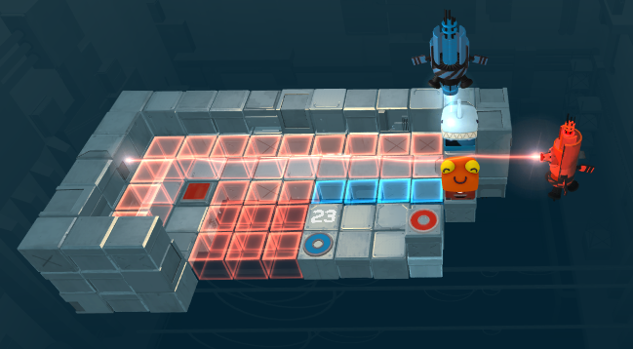
Level 14 Version 8
To make the blue player’s movements more of a threat to the red player, replaced the spikes with a downward-pointing blue laser that follows the red player’s x-axis. This means that when the red player needs to move up to the top row the blue player needs to remain above it blocking the laser. I also added some more floors and walls to make staying inside the level easier.
- Players need to use each other to win – SUCCESS
- Players can kill each other – SUCCESS
- Difficulty is in problem solving, not in executing the solution – SUCCESS
- Every block should only have one element, for clarity’s sake – SUCCESS
- Avoid levels that encourage taking advantage of getting stuck on walls (the splitting levels) – SUCCESS
- Levels with multiple of the same colour player are particularly tricky to get right – SUCCESS
- Path should be clear, but requires cooperation between players (my last two levels in the current build are a good example of this) – SUCCESS
- If the two players aren’t communicating with each other when playing, the level needs to change so that they have to – UNTESTED
- Avoid soft locks – killing the player is fine, but putting the player in a position where they are forced to make the decision to kill themselves in order to restart is not a great experience, especially in multiplayer – SUCCESS
- If a level ends up feeling like it has two disparate ideas, split into two levels, hone the single ideas more (per level) – SUCCESS
- If there's a difficult part of a level, front-load it in the sequence – SUCCESS
Score: 10/11

